Image | File name | Caption
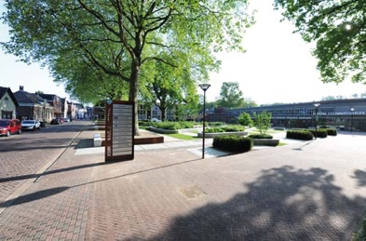 | RichardBrink_Zevenaar_01 | The remodelled Melangeursplein square in the Dutch city of Zevenaar combines historical industrial architecture with open, green recreational spaces.  Photo: Richard Brink GmbH & Co. KG
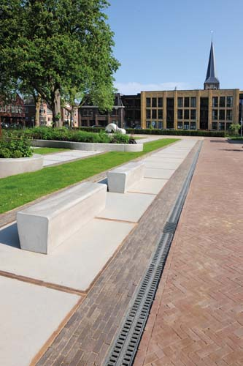 | RichardBrink_Zevenaar_02 | The Mono-Fortis heavy-duty channel produced by Richard Brink facilitates linear dewatering along the paved sections of the square.  Photo: Richard Brink GmbH & Co. KG
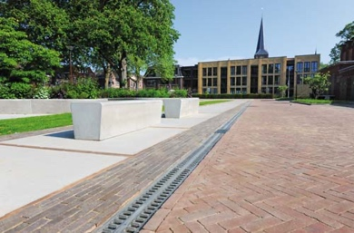 | RichardBrink_Zevenaar_03 | The monolithic channel elements made from polymer concrete blend seamlessly into the paving to create a clear, continuous line.  Photo: Richard Brink GmbH & Co. KG
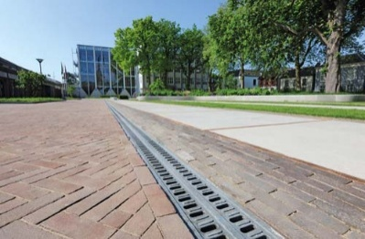 | RichardBrink_Zevenaar_04 | The channel bodies and gratings in the Mono-Fortis range are comprised of a single polymer-concrete component. Despite its comparatively light weight, the channel is extremely resilient, meeting the requirements of load class E 600.  Photo: Richard Brink GmbH & Co. KG
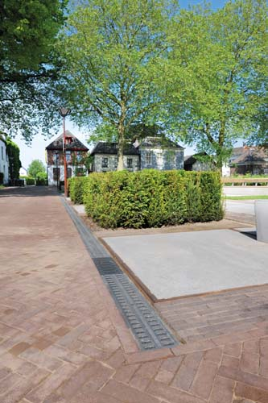 | RichardBrink_Zevenaar_05 | A total of four drainage units with matching Zippa designer cast gratings complete the 66-metre-long dewatering line.  Photo: Richard Brink GmbH & Co. KG
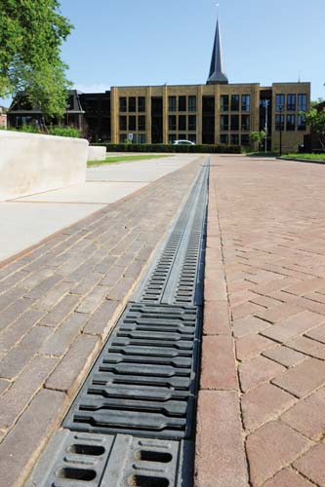 | RichardBrink_Zevenaar_06 | In combination, the polymer-concrete channels and drainage units impress with their high load capacity while still blending discreetly into the public space.  Photo: Richard Brink GmbH & Co. KG

