Image | File name | Caption
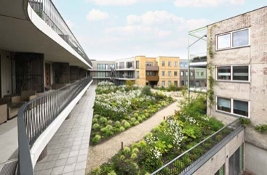 | RichardBrink_Purmerend_01 | In the Dutch town of Purmerend, on top of the car park that sits below the Lusthof residential complex, a rooftop garden has been created which features bushes, shrubs and trees, and is traversed by paths made of Padvast, a gravel surface bound by clay.  Photo: Richard Brink GmbH & Co. KG
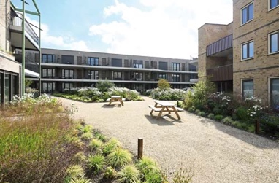  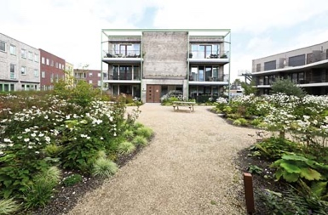 | RichardBrink_Purmerend_02A  RichardBrink_Purmerend_02B | Positioned between the vast flowerbeds and modern façades of the publicly accessible outdoor area, picnic tables invite visitors to wind down in the oasis of calm that forms the heart of the housing complex.  Photos: Richard Brink GmbH & Co. KG
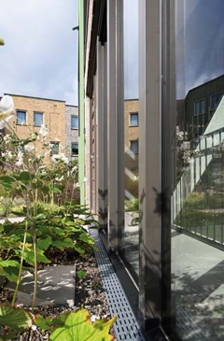  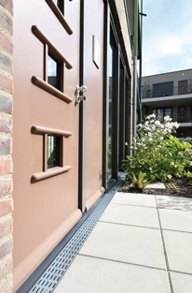 | RichardBrink_Purmerend_03A  RichardBrink_Purmerend_03B | Stabile drainage channels from the company Richard Brink were installed as part of the space’s newly designed irrigation and dewatering system. The channels ensure the controlled drainage of accumulating precipitation directly into the surrounding flowerbeds.  Photos: Richard Brink GmbH & Co. KG
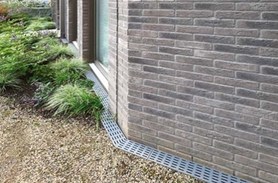  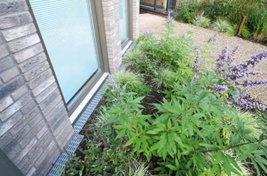 | RichardBrink_Purmerend_04A  RichardBrink_Purmerend_04B | As they trace the lines of the façades, the channels provided by the metal products manufacturer from Eastern Westphalia intentionally highlight the exterior wall projections in the door and reveal areas.  Photos: Richard Brink GmbH & Co. KG
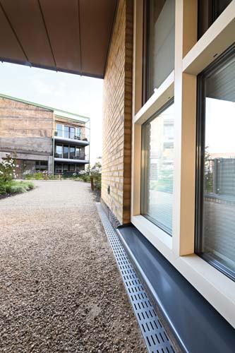  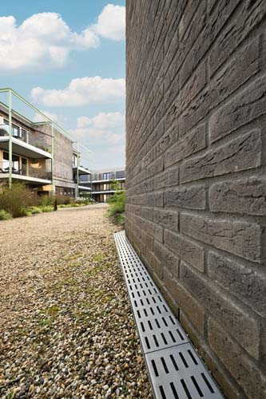 | RichardBrink_Purmerend_05A  RichardBrink_Purmerend_05B | Together with the colourful clinker walls and large-scale greenery, the housing complex now boasts appealing and contrasting colour combinations, which are further accentuated by the perforated gratings.  Photos: Richard Brink GmbH & Co. KG

