Image | File name | Caption
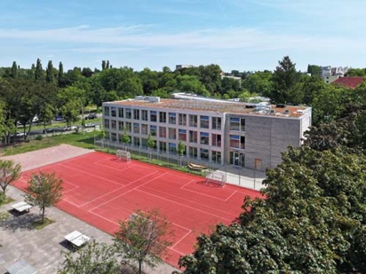 | RichardBrink_HomebBerlin_01 | In 2017, the city of Berlin launched an investment programme for the school building campaign “Berliner Schulbauoffensive”, aimed at meeting the increasing demand for school places. In doing this, it utilises modular timber structures, among other things.  Photo: Richard Brink GmbH & Co. KG
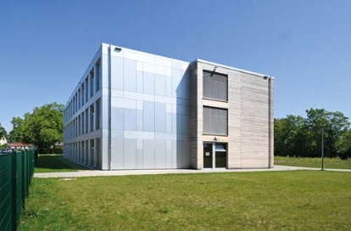 | RichardBrink_HomebBerlin_02 | Architecture office NKBAK from Frankfurt am Main designed a ten-metre-high, 52m x 20m structure comprising 96 room modules with a gross floor area of 2,950m² split over three levels.  Photo: Richard Brink GmbH & Co. KG
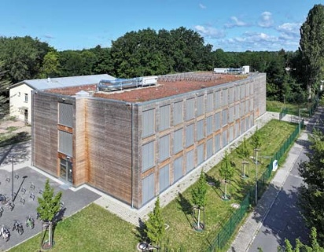 | RichardBrink_HomebBerlin_03 | In terms of façade dewatering, Austrian general planner Kaufmann Bausysteme opted to use the Stabile Air drainage channel produced by Richard Brink GmbH & Co. KG for the modular timber extension buildings (HOMEB).  Photo: Richard Brink GmbH & Co. KG
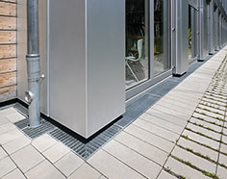 | RichardBrink_HomebBerlin_04 | As well as the façade channels, inner corners, outer corners and gullies were also supplied by the metal products manufacturer from Eastern Westphalia, along with precisely-fitting mesh gratings with sections cut out to fit around drain pipes.  Photo: Richard Brink GmbH & Co. KG
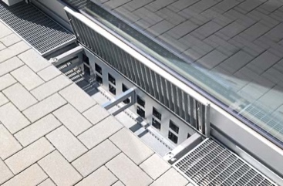 | RichardBrink_HomebBerlin_05 | Thanks to its ventilation openings, the Stabile Air keeps the façade ventilated at all times. The distance between the channel and the façade prevents water from rising through capillary forces, keeping the wood permanently protected from moisture.  Photo: Richard Brink GmbH & Co. KG
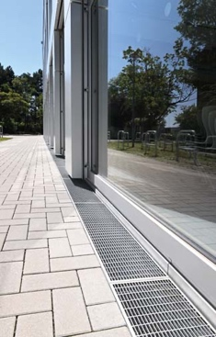 | RichardBrink_HomebBerlin_06 | A total of 141 metres of the channel was custom made from hot-dip galvanised steel to trim the building and surround its base. Alongside various standard measurements, the manufacturer also offers custom measurements with additional projections to fit door and window reveal depths as well as compatible gratings, always ensuring a technically correct and visually appealing finish.  Photo: Richard Brink GmbH & Co. KG
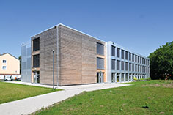 | RichardBrink_HomebBerlin_07 | The façades themselves are manufactured from spruce wood and aluminium sheets. As the modules are supplied up to 90% prefabricated, tradespeople can work together well on the construction site, reducing the build time of a HOMEB construction to a maximum of four months.  Photo: Richard Brink GmbH & Co. KG
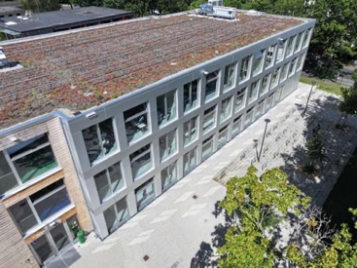 | RichardBrink_HomebBerlin_08 | Depending on site conditions, the extensive green roofs are furnished with various structures to hold a photovoltaic system, allowing the HOMEB schools to also score sustainability points.  Photo: Richard Brink GmbH & Co. KG
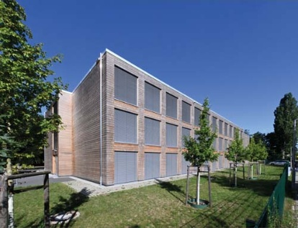 | RichardBrink_HomebBerlin_09 | The barrier-free buildings with their 16 classrooms, eight common rooms and a dining hall provide space for over 400 pupils. With 32 structures in total, the project will create around 13,000 new school places across Berlin.  Photo: Richard Brink GmbH & Co. KG

