Image | File name | Caption
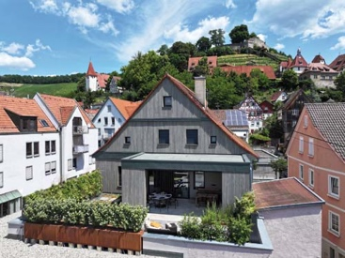 | RichardBrink_EvaBeilstein_01 | At the foot of Hohenbeilstein Castle in Beilstein, northeastern Baden-Wuerttemberg, the entire rear façade of the former district office and vicarage was renovated and a green roof terrace was created.  Photo: Richard Brink GmbH & Co. KG
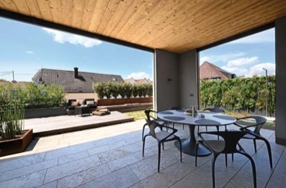 | RichardBrink_EvaBeilstein_02 | A covered space was constructed as an entrance area, which is surrounded by an L-shaped terrace. The space allows residents to enjoy the fresh air, even if the weather is bad.  Photo: Richard Brink GmbH & Co. KG
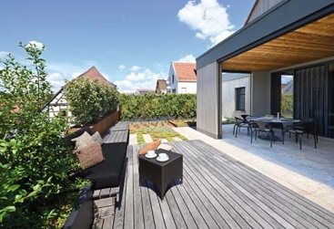 | RichardBrink_EvaBeilstein_03 | Seating positioned on raised decking in front of the new covered space provides a place to relax. Eva living walls produced by the company Richard Brink form an appealing privacy screen and frame either end of the terrace.  Photo: Richard Brink GmbH & Co. KG
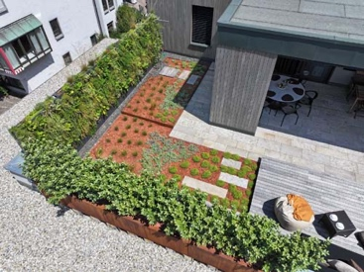 | RichardBrink_EvaBeilstein_04 | Generous flowerbeds featuring red substrate sit adjacent to the decking and continue around the corner. They create bold contrasts and fit perfectly with the overall look of the newly constructed oasis of calm.  Photo: Richard Brink GmbH & Co. KG
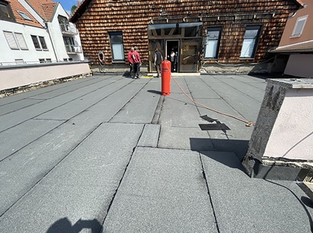 | RichardBrink_EvaBeilstein_05 | The living area used to lead out to a sparse outdoor area, set against a façade of old wooden shingles.  Photo: Benjamin Klotz, KLOTZ | garten
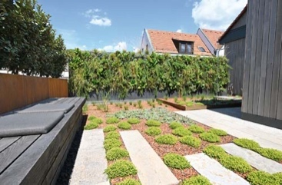 | RichardBrink_EvaBeilstein_06 | The flooring in the newly created space features long, light-coloured natural-stone slabs. The slabs also span the flowerbeds at two points, acting as a zebra crossing while allowing easier access to and upkeep of the flowerbeds.  Photo: Richard Brink GmbH & Co. KG
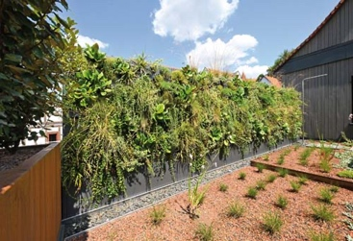 | RichardBrink_EvaBeilstein_07 | The living walls – one a line of four and the other a line of two structures – add continuous green expanses to the terrace that not only provide privacy and look great, but also enhance the space’s ecological value.  Photo: Richard Brink GmbH & Co. KG
 | RichardBrink_EvaBeilstein_08 | To avoid competing with the floor-level planting, the lower section of the vertical gardens was deliberately left as a neutral base. The company Richard Brink offers various ways to configure its Eva living wall.  Photo: Richard Brink GmbH & Co. KG
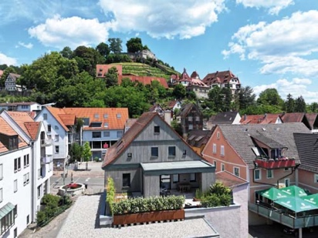 | RichardBrink_EvaBeilstein_09 | The planted wraparound privacy screen takes the form of corten-steel plant boxes along the length of the terrace. The old half-timbered house now presents a masterful balance of historical and modern architecture.  Photo: Richard Brink GmbH & Co. KG

