Image | File name | Caption
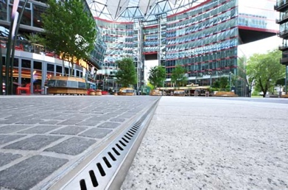 | RichardBrink_CenterPotsdamerPlatz_01 | Refurbishment of the outdoor areas of Das Center am Potsdamer Platz saw not only several elements being restructured but, most notably, a redesigned dewatering system with custom channels from the company Richard Brink.  Photo: Richard Brink GmbH & Co. KG
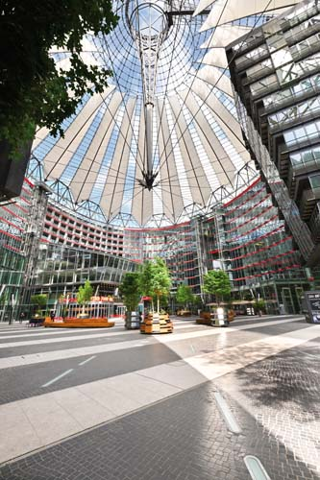 | RichardBrink_CenterPotsdamerPlatz_02 | The complex is representative of modern city life and comprises, among other things, residential and commercial spaces as well as restaurants and a cinema. The entire area is crowned by a distinctive tent-like dome – a symbol of the circular building ensemble, also beyond the city limits.  Photo: Richard Brink GmbH & Co. KG
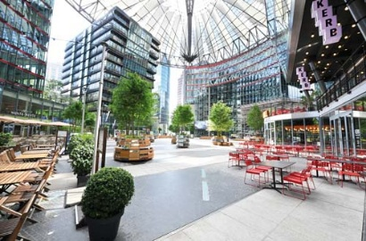 | RichardBrink_CenterPotsdamerPlatz_03 | During the redesign, special attention was given to maintaining the site’s DNA. For example, the pattern of alternating stripes will continue to adorn the floor in the outdoor area. The previous planting elements, however, were replaced with modern stainless-steel plant pots, which can be easily rearranged to change the look and feel of the space thanks to their castor fixtures.  Photo: Richard Brink GmbH & Co. KG
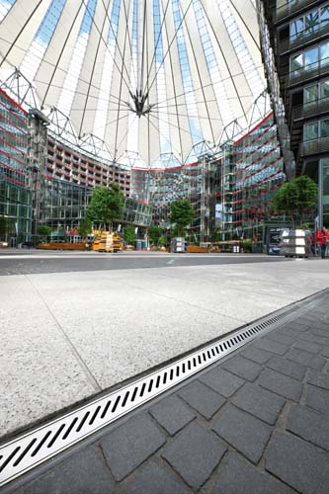 | RichardBrink_CenterPotsdamerPlatz_04 | The dark paving was also retained in line with the concept of strengthening existing design by combining it with new elements. Light-coloured granite slabs have, however, replaced the worn-out stainless-steel panels. The new lines of channels, whose slot perforations take inspiration from the pattern of the former metal surface, direct accumulating rainwater into a 5cm-deep hollow space that sits underneath and leads the water into the sewer system.  Photo: Richard Brink GmbH & Co. KG
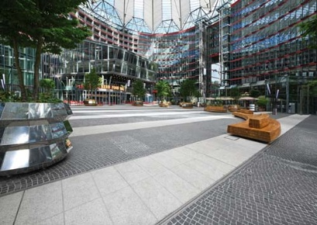 | RichardBrink_CenterPotsdamerPlatz_05 | The new stainless steel channels produced by the metal products manufacturer from Eastern Westphalia were designed to blend in with the striped pattern, continue using the existing hollow space, and display the same slot perforation as the previous dewatering solution.  Photo: Richard Brink GmbH & Co. KG
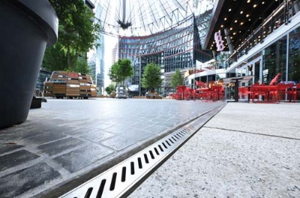 | RichardBrink_CenterPotsdamerPlatz_06 | The medium-sized, family-run company developed the channel based on these specifications as an entirely bespoke, small-scale product. For Richard Brink GmbH & Co. KG, Das Center am Potsdamer Platz is one of several prestige projects in the German capital to feature the company’s drainage and dewatering systems.  Photo: Richard Brink GmbH & Co. KG

