Image | File name | Caption
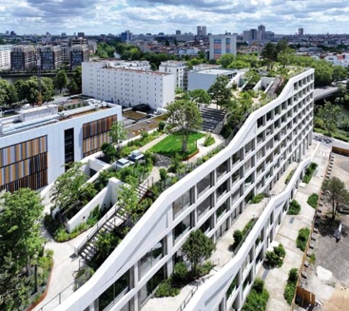 | RichardBrink_AERABerlin_01 | A striking office complex has emerged in Charlottenburg-Wilmersdorf that impresses not only through its interior, featuring a six-metre-high foyer and conference areas complete with a panoramic view, but most of all through its unique rooftop garden.  Photo: Richard Brink GmbH & Co. KG
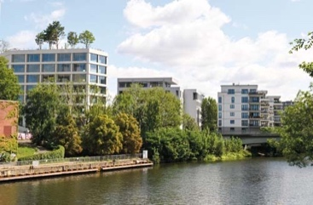 | RichardBrink_AERABerlin_02 | Located on Mierendorff Island between the River Spree and Westhafen Canal, the project is part of a larger initiative to transform Charlottenburg’s former power station site. The AERA construction fits in well with the surrounding new builds while still managing to stand out with its intensive roof planting.  Photo: Richard Brink GmbH & Co. KG
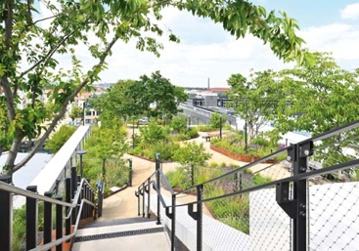 | RichardBrink_AERABerlin_03 | When designing the outdoor area, products provided by Richard Brink, such as dewatering channels with cast gratings, were incorporated from ground level all the way up to the rooftop. Moreover, corten steel planting systems produced by the family-run company set the scene for the stunning greenery.  Photo: Richard Brink GmbH & Co. KG
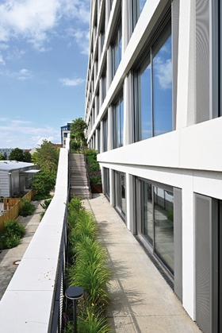  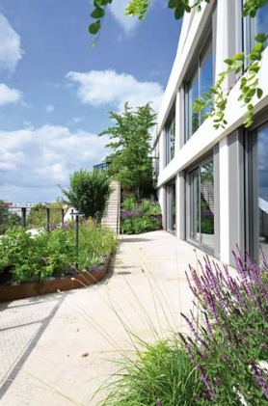 | RichardBrink_AERABerlin_04A  RichardBrink_AERABerlin_04B | Planting also runs along the entire staircase that gives each rental unit its own outdoor access point, adding a splash of green to the entire structure from top to bottom. In the reveal areas along the doors and windows of the glass façade, Fortis concrete channels are combined with Zippa cast iron designer gratings to ensure top quality dewatering.  Photos: Richard Brink GmbH & Co. KG
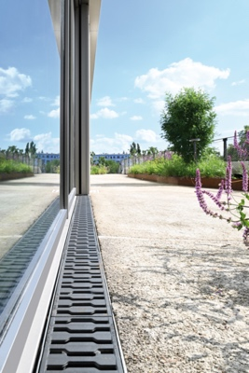  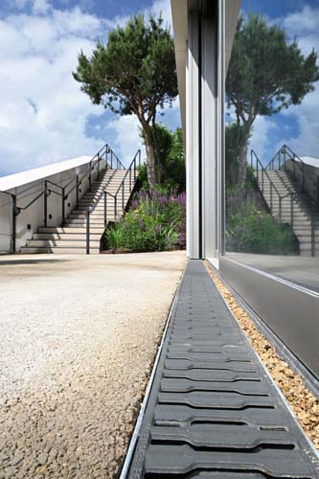 | RichardBrink_AERABerlin_05A  RichardBrink_AERABerlin_05B | Together with the water-bound path surfaces made from Glorit cement, the combination of channel and grating forms part of the rainwater management concept. Any accumulating water is temporarily stored and directed towards the vegetation.  Photos: Richard Brink GmbH & Co. KG
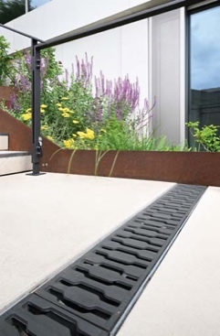 | RichardBrink_AERABerlin_06 | The concrete channels produced by the Eastern Westphalia-based manufacturer are also used to drain the stairway sections.  Photo: Richard Brink GmbH & Co. KG
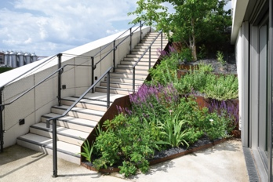  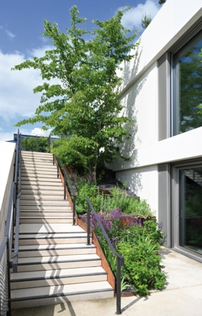 | RichardBrink_AERABerlin_07Q  RichardBrink_AERABerlin_07H | Along the steps, elements made from corten steel function as stair stringers and flower bed edging solutions in one. The company Richard Brink implemented all kinds of requirements to create individual custom solutions for the 2,200m² of total roof space.  Photos: Richard Brink GmbH & Co. KG
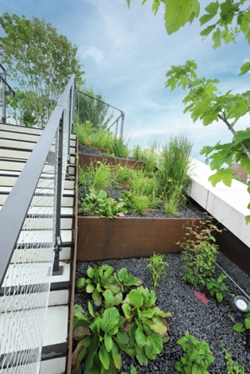 | RichardBrink_AERABerlin_08 | For example, the raised beds that run alongside the storey transitions were also positioned in vertical sections, perfectly highlighting the building’s integrated concept of ecological added value and on-site water management.  Photo: Richard Brink GmbH & Co. KG
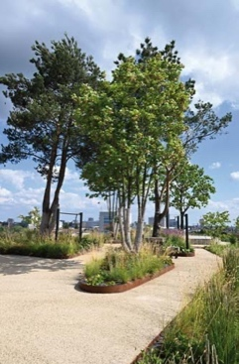  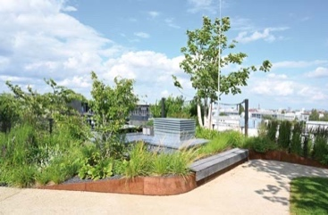 | RichardBrink_AERABerlin_09H  RichardBrink_AERABerlin_09Q | Semira raised beds in various heights and shapes are inserted into the 480 metres of paved surfaces so as to create little islands. Their edges are bordered with 3.0mm-thick Ora Max steel strip edgings. The beds are home to more than 35 plant species in total, including trees standing up to 12 metres tall.  Photos: Richard Brink GmbH & Co. KG
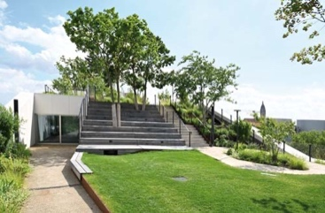 | RichardBrink_AERABerlin_10 | Some of the raised beds are fitted with benches, making for a creatively designed park area with no fixed arrangement that incorporates various oases of calm. A particular highlight is the central transition between the storeys, which is designed to serve as stands for events.  Photo: Richard Brink GmbH & Co. KG
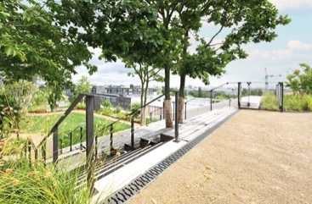 | RichardBrink_AERABerlin_11 | Combined with the Zippa cast gratings, the 80mm-high concrete channels produced by Richard Brink GmbH & Co. KG also underscore the building’s colour concept, characterised by dark railings and stripes across the stairways.  Photo: Richard Brink GmbH & Co. KG
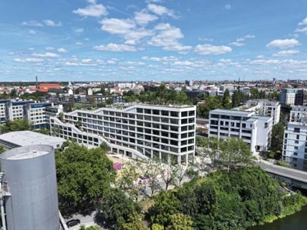 | RichardBrink_AERABerlin_12 | This truly green building accomplishes a smooth transition between construction and nature and slots ideally into its surroundings along the banks of the Spree.  Photo: Richard Brink GmbH & Co. KG

