Image | File name | Image caption
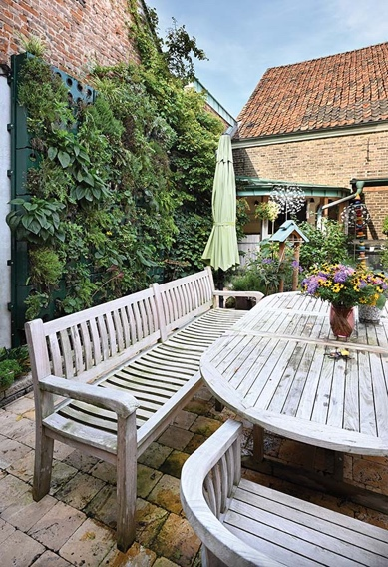 | RichardBrink_AdamWesel_01 | Adam modular living walls from Richard Brink were used for a sustainable planting project in the courtyard of a private house in Wesel, North-Rhine Westphalia.  Photo: Richard Brink GmbH & Co. KG
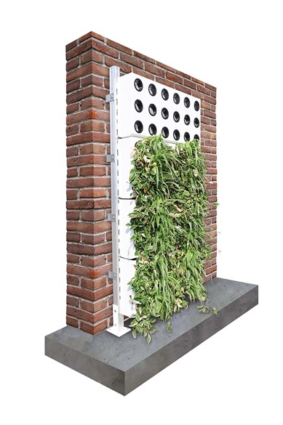 | RichardBrink_AdamWesel_02 | A substructure with additional screwable feet for mounting on a foundation was selected along with matching vertical plant cassettes. The metal products manufacturer offers alternative substructures for self-supporting wall-mounting and also external wall insulation systems.  Photo: Richard Brink GmbH & Co. KG
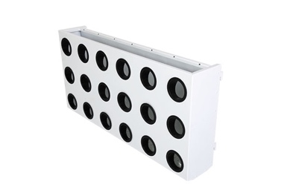 | RichardBrink_AdamWesel_03 | Once the vertical plant cassettes have been hooked directly into the substructure mounting rails, the plants are inserted from the side.  Photo: Richard Brink GmbH & Co. KG
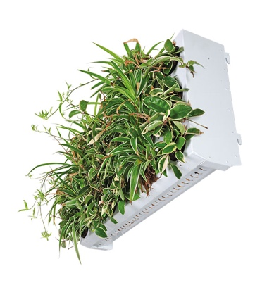 | RichardBrink_AdamWesel_04 | When fully planted, the cassettes create a seamless green surface. Drainage slits beneath the cassette bodies allow precipitation and irrigation water to percolate through to the modules below.  Photo: Richard Brink GmbH & Co. KG
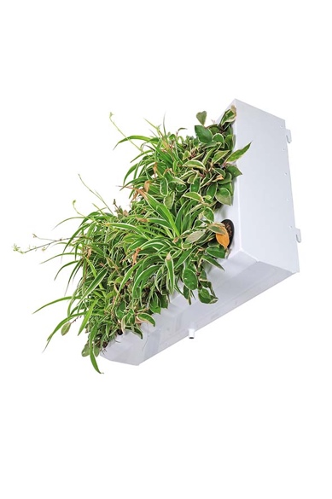 | RichardBrink_AdamWesel_05 | The bottom row of the plant cassettes always features a drain nozzle to channel away the remaining water in a safe and controlled manner.  Photo: Richard Brink GmbH & Co. KG
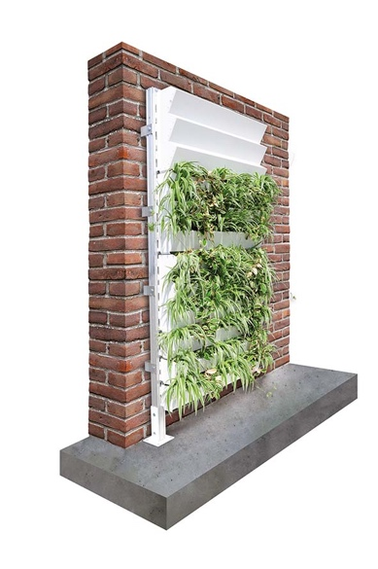 | RichardBrink_AdamWesel_06 | Depending on taste, customers can also opt for a stepped version of the plant cassettes. Plants are inserted into these directly from above.  Photo: Richard Brink GmbH & Co. KG
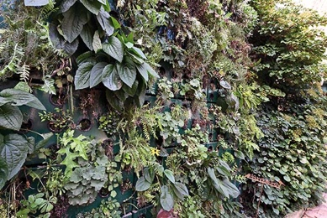 | RichardBrink_AdamWesel_07 | Lush greenery extends across almost the entire surface of the living wall in the inner courtyard of the property in Wesel. This is not only visually striking, but also helps cool the courtyard on hot days.  Photo: Richard Brink GmbH & Co. KG

