Image | File name | Caption
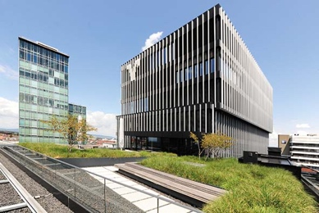 | RichardBrink_VolksbankFreiburg_01.jpg | The new Volksbank Freiburg building complex impresses with its creative overall concept and its utilisation as a multifunctional area.  Photo: Richard Brink GmbH & Co. KG
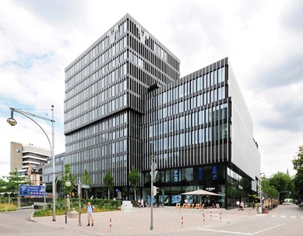 | RichardBrink_VolksbankFreiburg_02.jpg | The striking façade features floor-to-ceiling windows set behind a curtain-wall lamellar structure, which appears to hover in front of the building’s outer shell.  Photo: Richard Brink GmbH & Co. KG
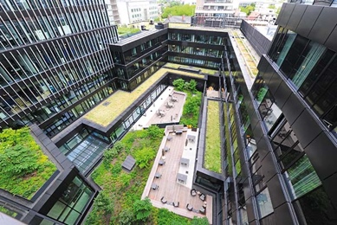 | RichardBrink_VolksbankFreiburg_03.jpg | A number of cubic building elements create different levels that encompass a planted inner courtyard.  Photo: Richard Brink GmbH & Co. KG
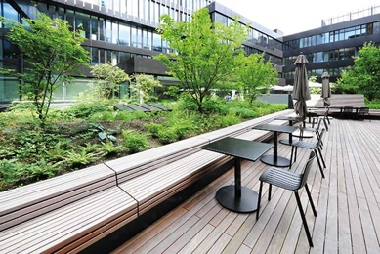 | RichardBrink_VolksbankFreiburg_04.jpg | Raised beds from the company Richard Brink act as dividers in the courtyard, which is used by both Volksbank Freiburg and an adjoining hotel.  Photo: Richard Brink GmbH & Co. KG
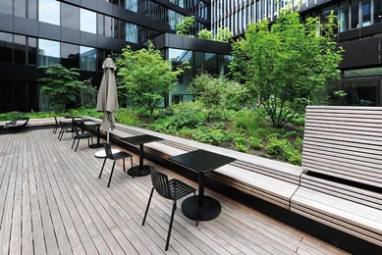 | RichardBrink_VolksbankFreiburg_05.jpg | Integrated wooden seating provides space to relax or work outside. Optically, the benches flow right down into the terrace flooring.  Photo: Richard Brink GmbH & Co. KG
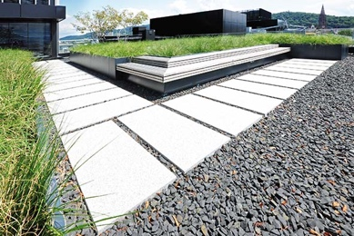 | RichardBrink_VolksbankFreiburg_06.jpg | Two additional, separately accessible terraces were also fitted with aluminium planting systems made by the metal products manufacturer.  Photo: Richard Brink GmbH & Co. KG
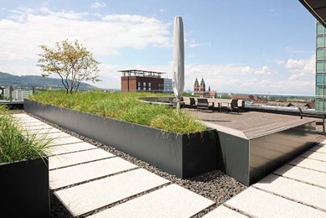 | RichardBrink_VolksbankFreiburg_07.jpg | The raised beds divide the outside area here, too, creating enclosed green spaces with their height and use of planting.  Photo: Richard Brink GmbH & Co. KG
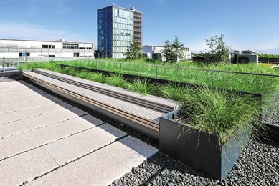 | RichardBrink_VolksbankFreiburg_08.jpg | The transition between plant beds and seating areas is practically seamless – a clever combination of outdoor furniture and greenery.  Photo: Richard Brink GmbH & Co. KG
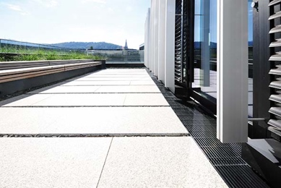 | RichardBrink_VolksbankFreiburg_09.jpg | The broad range of products offered by the company Richard Brink is beautifully showcased here. Besides raised beds, the façade area also features drainage channels from the metal products manufacturer.  Photo: Richard Brink GmbH & Co. KG
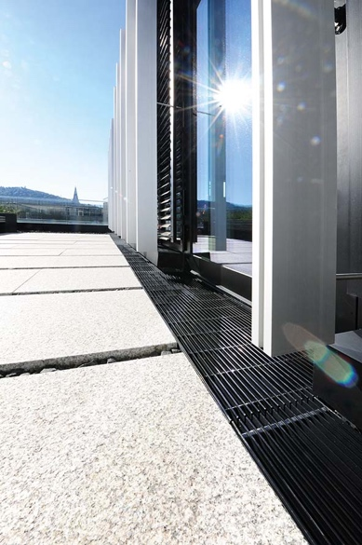 | RichardBrink_VolksbankFreiburg_10.jpg | The Stabile models reliably collect rainwater and direct it away from the building. Both the channels and the 20 x 3mm longitudinal bar gratings were finished in a graphite black plastic coating.  Photo: Richard Brink GmbH & Co. KG
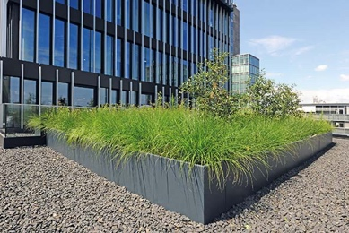 | RichardBrink_VolksbankFreiburg_11.jpg | As a low-maintenance and robust type of planting, grasses dominate the planting systems on the elevated terraces.  Photo: Richard Brink GmbH & Co. KG
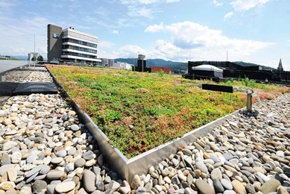 | RichardBrink_VolksbankFreiburg_12.jpg | The company Richard Brink supplied a total of 882m of its substrate rails for the roof beds, which elegantly frame the sedum mat.  Photo: Richard Brink GmbH & Co. KG
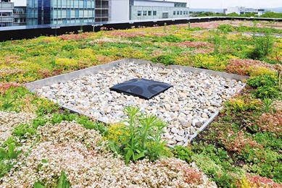 | RichardBrink_VolksbankFreiburg_13.jpg | The substrate rails reliably separate the planted areas from the adjacent gravel fill. They also enable the flow of any rainfall.  Photo: Richard Brink GmbH & Co. KG
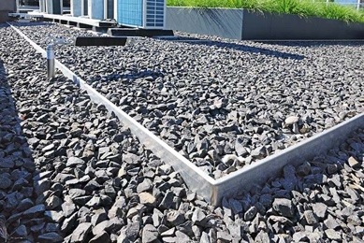 | RichardBrink_VolksbankFreiburg_14.jpg | The substrate rails can further be used to create divisions between different roof spaces featuring gravel beds.  Photo: Richard Brink GmbH & Co. KG
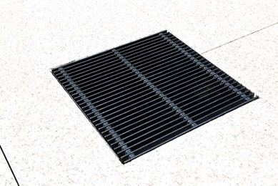 | RichardBrink_VolksbankFreiburg_15.jpg | In some places on the site, drainage gullies provide selective support for the drainage system.  Photo: Richard Brink GmbH & Co. KG
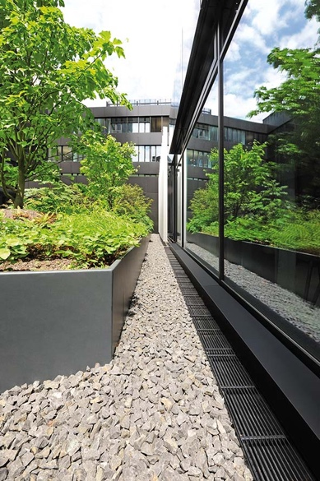 | RichardBrink_VolksbankFreiburg_16.jpg | This project underlines the depth and diversity of Richard Brink's product range. From the planting systems to the drainage solutions, everything was supplied from a single source.  Photo: Richard Brink GmbH & Co. KG

