Image | File name | Caption
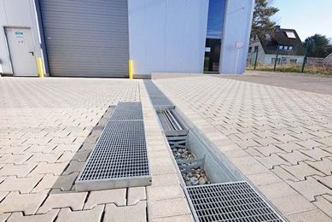 | RichardBrink_ParkerHannifin_01.jpg | Permeable RigoMax gravel-filled drainage channels from the company Richard Brink were installed on the company premises of Parker Hannifin Manufacturing Germany GmbH & Co. KG.  Photo: Richard Brink GmbH & Co. KG
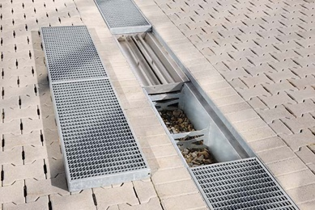 | RichardBrink_ParkerHannifin_02.jpg | The channels are ideal for the temporary storage and subsequent gradual drainage of large quantities of water. What’s more, they feature up to two integrated filter inserts.  Photo: Richard Brink GmbH & Co. KG
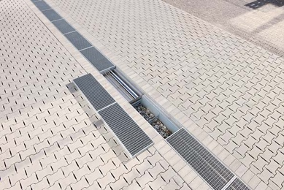 | RichardBrink_ParkerHannifin_03.jpg | Richard Brink supplied a total of twelve custom-made channel bodies for the project, each with a length of one metre.  Photo: Richard Brink GmbH & Co. KG
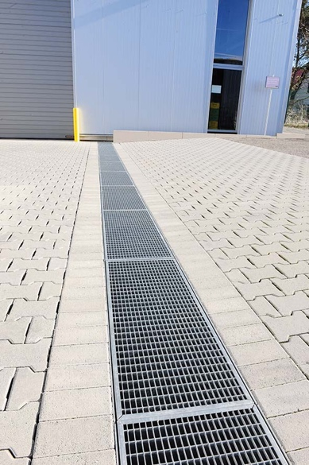 | RichardBrink_ParkerHannifin_04.jpg | Heavy-duty gratings made to measure from hot-dip galvanised steel sheeting cover the channels.  Photo: Richard Brink GmbH & Co. KG
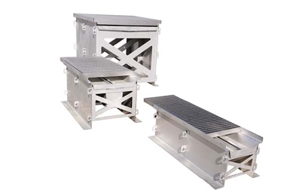 | RichardBrink_ParkerHannifin_05.jpg | The metal products manufacturer offers the RigoMax channels in a variety of lengths, widths and heights. Storage volumes therefore range from 90 to 970 litres.  Photo: Richard Brink GmbH & Co. KG
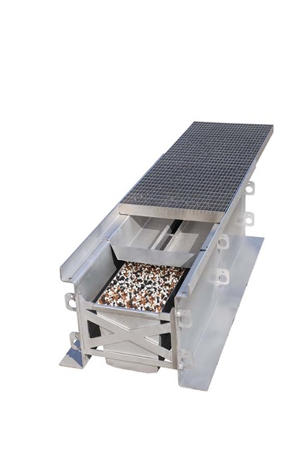 | RichardBrink_ParkerHannifin_06.jpg | While the upper filter insert is able to hold back coarse dirt as well as tyre wear particles and microplastics thanks to its upturned edges, the additional lower insert is able to filter out substances contained in the water.  Photo: Richard Brink GmbH & Co. KG
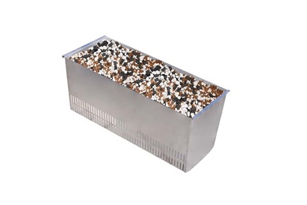 | RichardBrink_ParkerHannifin_07.jpg | Thanks to its ability to sift out components such as heavy metals effectively, the optional second filter also meets regulations often applicable in public areas.  Photo: Richard Brink GmbH & Co. KG

