Image | File name | Caption
 | RichardBrink_MiraluxGT_01 | An 8.88 kWp photovoltaic system was installed on a residential building in Gütersloh, Germany. Miralux Flex solar substructures from Richard Brink formed the basis of the system.  Photo: Richard Brink GmbH & Co. KG
 | RichardBrink_MiraluxGT_02 | East-west-facing substructures were selected for the project to ensure continual energy generation throughout the day.  Photo: Richard Brink GmbH & Co. KG
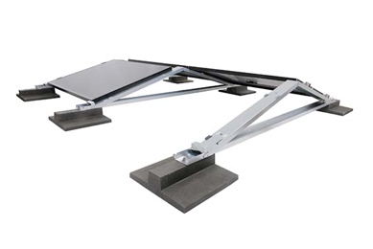 | RichardBrink_MiraluxGT_03 | The modular Miralux Flex systems impress with their rapid, tool-free installation with no penetration of the roof surface.  Photo: Richard Brink GmbH & Co. KG
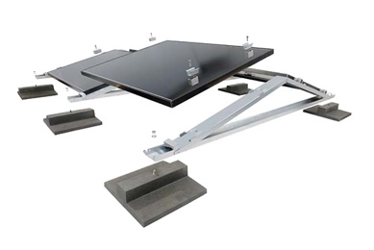 | RichardBrink_MiraluxGT_04 | Suitable module clamps for affixing commercially available solar panels are included with the module mounting systems.  Photo: Richard Brink GmbH & Co. KG
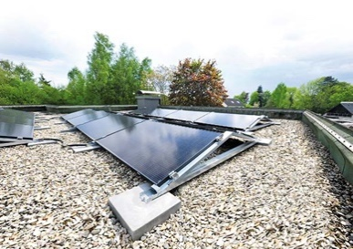 | RichardBrink_MiraluxGT_05 | The substructure was weighted down with screwable ballast blocks which are also manufactured by Richard Brink as per the ballast plan.  Photo: Richard Brink GmbH & Co. KG
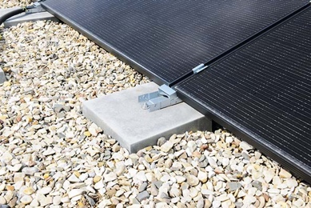 | RichardBrink_MiraluxGT_06 | To install the ballast, the existing gravel bed merely needed to be cleared in the area of the intended supporting bases.  Photo: Richard Brink GmbH & Co. KG
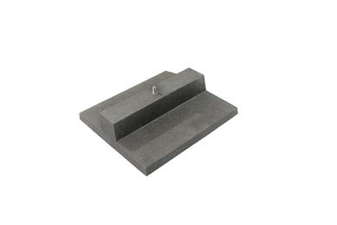 | RichardBrink_MiraluxGT_07 | The ballast blocks are available in two designs. Pictured here is the 16kg variant, which features a flat base panel and is ideal for almost invisible installation on gravel or green roofs.  Photo: Richard Brink GmbH & Co. KG
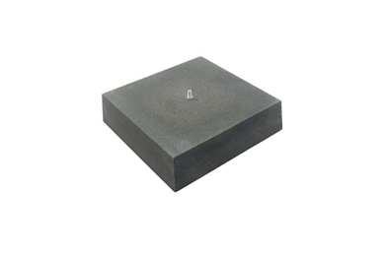 | RichardBrink_MiraluxGT_08 | A 34kg variant of the polymer concrete ballast blocks is also available.  Photo: Richard Brink GmbH & Co. KG

