Image | File name | Caption
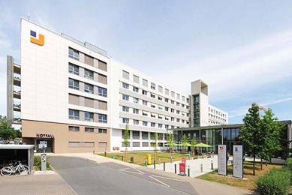 | RichardBrink_JosephsHospital_01.jpg | The new seven-storey extension building recently added to Josephs-Hospital in Warendorf houses not only an A&E department but also an intensive care unit and modern patient rooms.  Photo: Richard Brink GmbH & Co. KG
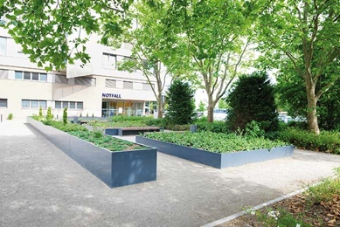 | RichardBrink_JosephsHospital_02.jpg | When planning the extension, importance was also placed on the design of the outdoor space. The goal was to create a green area that could be enjoyed by patients, staff and visitors alike.  Photo: Richard Brink GmbH & Co. KG
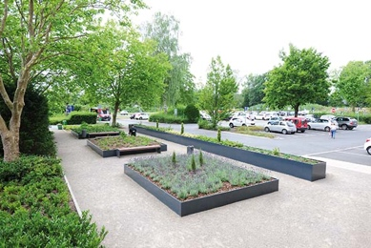 | RichardBrink_JosephsHospital_03.jpg | Large-scale, custom-made raised beds from the company Richard Brink with matching seating make for an inviting spot to watch the world go by.  Photo: Richard Brink GmbH & Co. KG
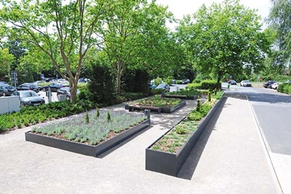 | RichardBrink_JosephsHospital_04.jpg | The metal products manufacturer produced a total of 100m of its raised bed walls from aluminium to create four raised beds.  Photo: Richard Brink GmbH & Co. KG
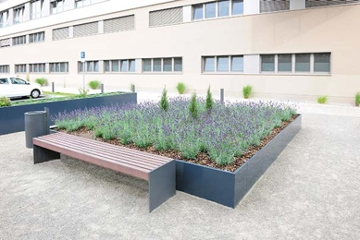 | RichardBrink_JosephsHospital_05.jpg | Benches featuring wooden seats were colour coordinated with the beds to form one harmonious whole.  Photo: Richard Brink GmbH & Co. KG
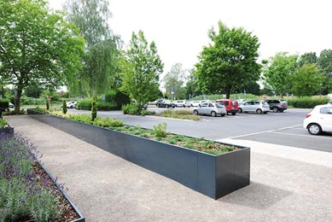 | RichardBrink_JosephsHospital_06.jpg | The raised design of the planting systems runs the entire length of the area, separating the green space from the car park.  Photo: Richard Brink GmbH & Co. KG
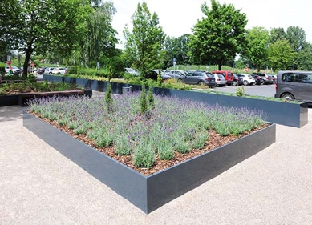 | RichardBrink_JosephsHospital_07.jpg | Evergreen plants, such as the extensive lavender bed shown here, make for an attractive display year-round.  Photo: Richard Brink GmbH & Co. KG

