Image | File name | Caption
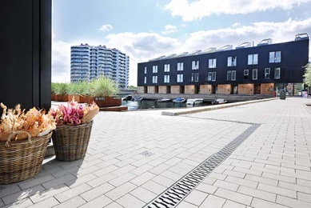 | RichardBrink_HafenKopenhagen_01 | Formerly a place of industry, Copenhagen’s South Harbour is now home to modern residential quarters with direct access to the water.  Photo: Richard Brink GmbH & Co. KG
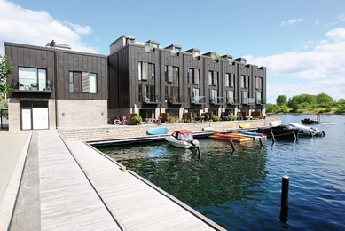 | RichardBrink_HafenKopenhagen_02 | Newly created piers on the Teglholmen peninsula provide a foundation for the exclusive residences, which comprise a total of 45 units.  Photo: Richard Brink GmbH & Co. KG
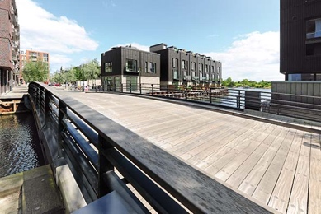 | RichardBrink_HafenKopenhagen_03 | In terms of style, the interconnected areas stand out for their mix of modernity and rustic charm.  Photo: Richard Brink GmbH & Co. KG
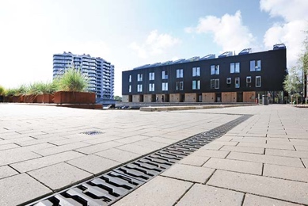 | RichardBrink_HafenKopenhagen_04 | Fortis concrete channels from the company Richard Brink with compatible Zippa cast gratings ensure reliable dewatering, for example in the harbour complex’s open spaces.  Photo: Richard Brink GmbH & Co. KG
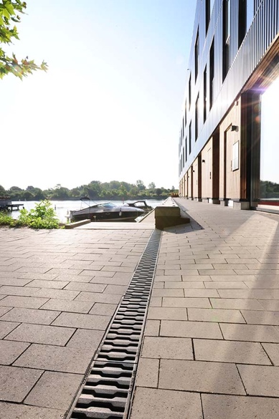 | RichardBrink_HafenKopenhagen_05 | The cast gratings especially stand out along the piers thanks to their unique look, which picks up on the South Harbour’s industrial past.  Photo: Richard Brink GmbH & Co. KG
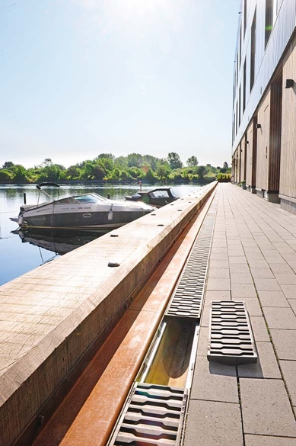 | RichardBrink_HafenKopenhagen_06 | The Fortis concrete channels meet D 400 load class requirements, while the Zippa cast gratings are designed to withstand loads of as high as E 600.  Photo: Richard Brink GmbH & Co. KG
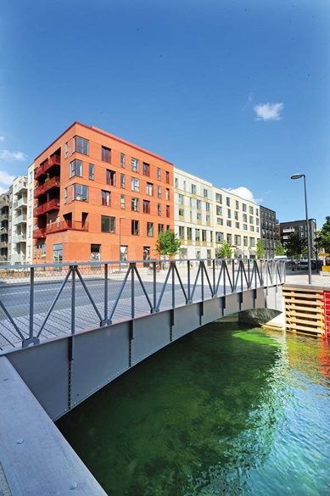 | RichardBrink_HafenKopenhagen_07 | Another residential quarter was constructed on a second peninsula in Teglholmen’s direct vicinity as part of the largest housing project to date in the Greater Copenhagen Region.  Photo: Richard Brink GmbH & Co. KG
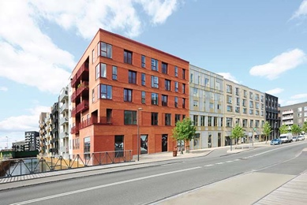 | RichardBrink_HafenKopenhagen_08 | The buildings catch the eye with their alternating light, dark and vibrant red brick façades.  Photo: Richard Brink GmbH & Co. KG
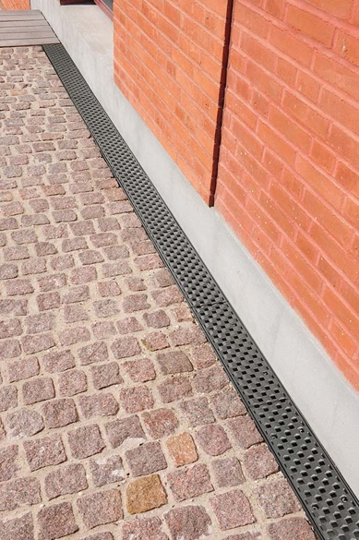 | RichardBrink_HafenKopenhagen_09 | Concrete channels from the metal products manufacturer were installed along the façade areas here too, this time in combination with the Prisma cast grating.  Photo: Richard Brink GmbH & Co. KG
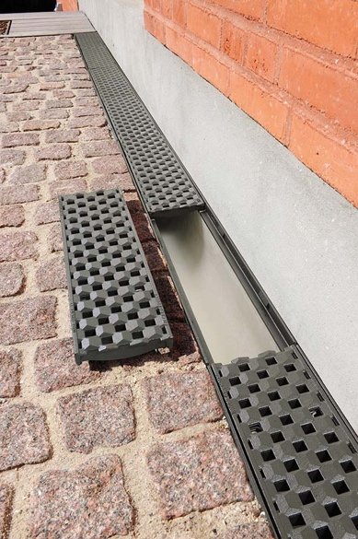 | RichardBrink_HafenKopenhagen_10 | The channels with their cast frames form an effective, practically seamless unit. The intricate surface of the Prisma add a profound layer of detail to the dewatering solution while creating bold contrasts with the paving and façade.  Photo: Richard Brink GmbH & Co. KG
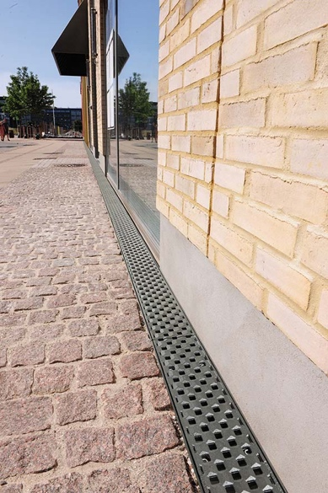 | RichardBrink_HafenKopenhagen_11 | The company Richard Brink produced around 150 metres of channels and gratings for the unique housing project on the Sluseholmen peninsula.  Photo: Richard Brink GmbH & Co. KG

