Image | File name | Caption
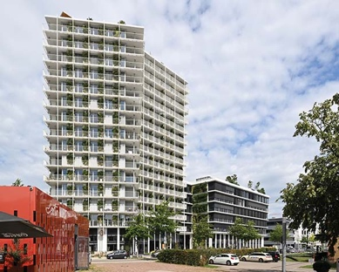 | RichardBrink_GreenCityTower_01 | The Green City Tower, which consists of multiple building parts, was constructed on the site of the former northern freight yard in Freiburg im Breisgau.  Photo: Richard Brink GmbH & Co. KG
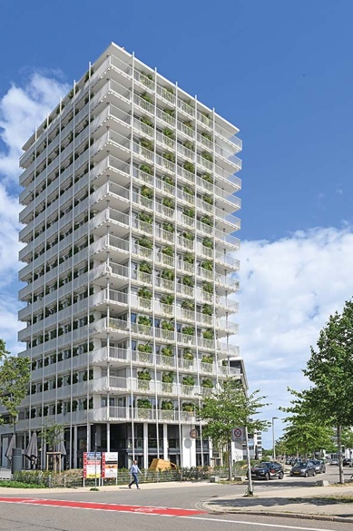 | RichardBrink_GreenCityTower_02 | The residential tower, which stands at a total height of 52 metres, cuts an imposing figure and offers the residents of the upper storeys views over the city’s roofs.  Photo: Richard Brink GmbH & Co. KG
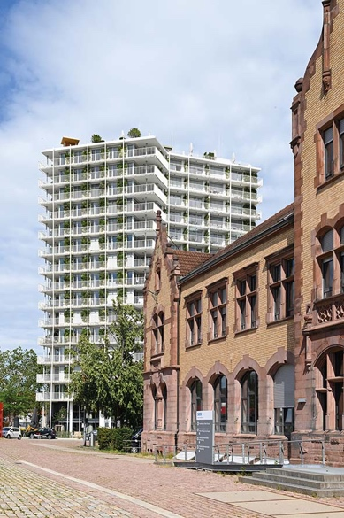 | RichardBrink_GreenCityTower_03 | The Green City Tower also offers generous office and catering space for businesses. With its striking architecture, it acts as the gateway to the newly developed district.  Photo: Richard Brink GmbH & Co. KG
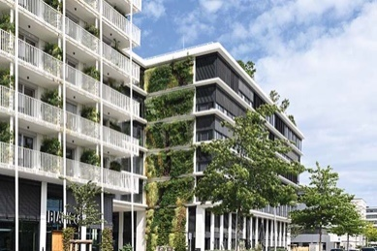 | RichardBrink_GreenCityTower_04 | A stand-out feature of the new building is its extensive façade greenery. Its scale makes it one of the largest vertical vegetation areas in Germany.  Photo: Richard Brink GmbH & Co. KG
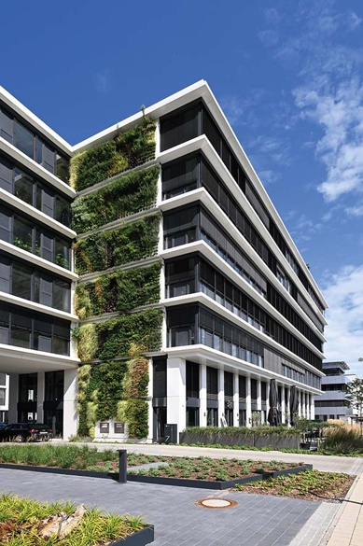 | RichardBrink_GreenCityTower_05 | Tasks entrusted to flor-design Wand GmbH included the installation of its own “greencityWALL” product solution. The structural part of the wall-mounted façade greenery was supplied by Richard Brink.  Photo: Richard Brink GmbH & Co. KG
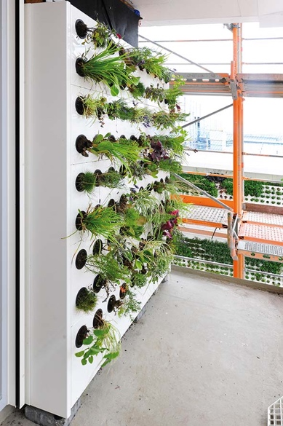 | RichardBrink_GreenCityTower_06 | Photos from the construction phase illustrate the structure of the living walls: front-mounted, rear-ventilated plant cassettes were fixed to the façade with the aid of mounting rails. Stands at ground level take the weight of the plant-bearing cassettes to support the façade.  Photo: Richard Brink GmbH & Co. KG
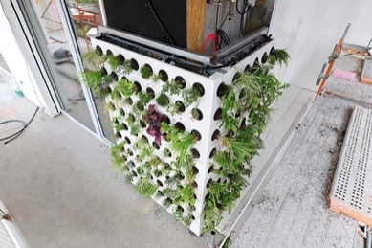 | RichardBrink_GreenCityTower_07 | Planting was done by inserting the plants into the corresponding cutouts from the side, alternating with the addition of the substrate from above. Irrigation hoses ensure even and automatic watering of the plants.  Photo: Richard Brink GmbH & Co. KG
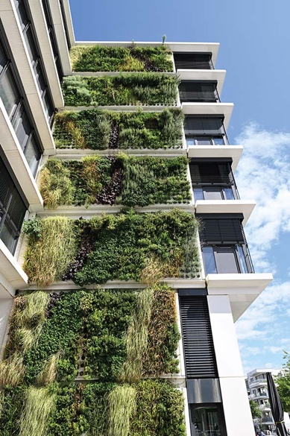 | RichardBrink_GreenCityTower_08 | The approx. 50,000 plants now make up a seamless green surface. This not only creates visual highlights, but also helps protect and insulate the building’s structural fabric. Additionally, it creates a valuable habitat, filters particulate matter out of the air and binds CO₂.  Photo: Richard Brink GmbH & Co. KG
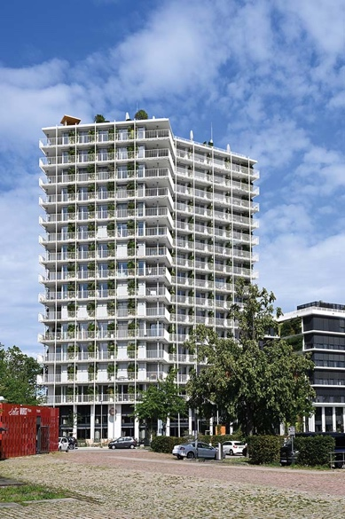 | RichardBrink_GreenCityTower_09 | The completed Green City Tower is the result of excellent cooperation between all project participants and is a shining example of sustainable, forward-looking city planning.  Photo: Richard Brink GmbH & Co. KG

