Image | File name | Caption
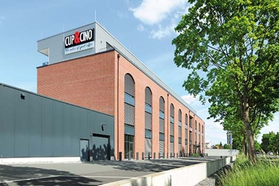 | RichardBrink_Cup&Cino_01 | The municipality of Hövelhof, Eastern Westphalia, is home to the new headquarters of CUP&CINO Kaffeesystem-Vertrieb GmbH & Co. KG, which spans an area of approx. 5,000 square metres.  Photo: Richard Brink GmbH & Co. KG
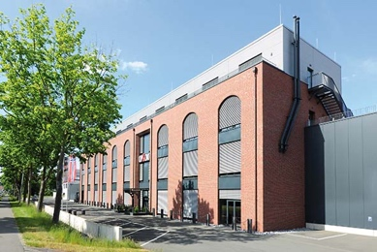 | RichardBrink_Cup&Cino_02 | With its brick façade, arched windows and profiled sheet cladding on the uppermost floor, the new build has the look of an old industrial building.  Photo: Richard Brink GmbH & Co. KG
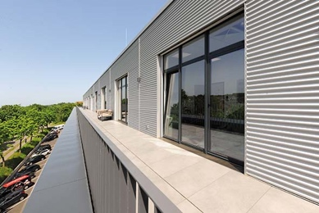 | RichardBrink_Cup&Cino_03 | A roof terrace runs the length of the set-back upper floor, allowing employees to work outside or simply relax in their breaks.  Photo: Richard Brink GmbH & Co. KG
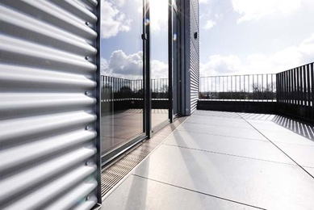 | RichardBrink_Cup&Cino_04 | Stabile drainage channels from the company Richard Brink collect any precipitation that accumulates in the reveal areas in front of the doors.  Photo: Richard Brink GmbH & Co. KG
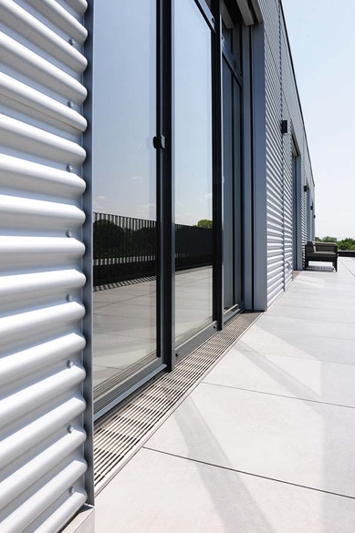 | RichardBrink_Cup&Cino_05 | Together with the 7 x 7mm longitudinal bar gratings made from stainless steel, the channels ensure a barrier-free transition between the offices and the outdoor area.  Photo: Richard Brink GmbH & Co. KG
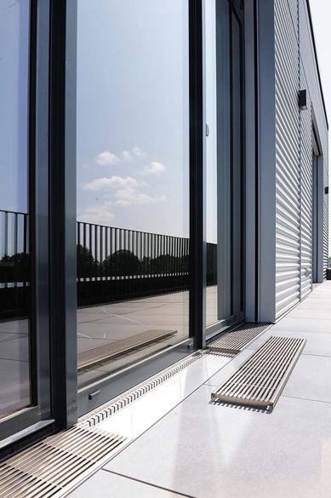 | RichardBrink_Cup&Cino_06 | The metal products manufacturer produced the Stabile channels with different inlet widths ranging from 145mm to 195mm, all with a height of 40mm.  Photo: Richard Brink GmbH & Co. KG
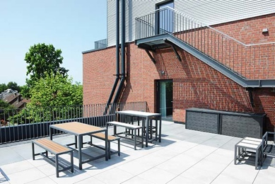 | RichardBrink_Cup&Cino_07 | A further outdoor area located on a lower level invites employees to come together and take a break.  Photo: Richard Brink GmbH & Co. KG
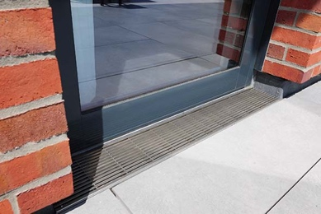 | RichardBrink_Cup&Cino_08 | This reveal area has also been fitted with a Stabile drainage channel. Here, the longitudinal bar grating cleverly contrasts with the brick façade and picks up on the mix of materials otherwise found throughout the building.  Photo: Richard Brink GmbH & Co. KG

