Image | File name | Caption
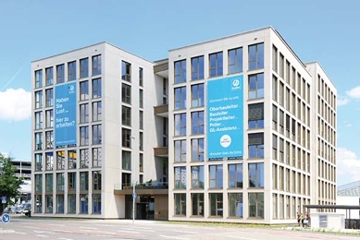 | RichardBrink_CarlsCube_01.jpg | Karlsruhe wholesale market is now home to CarlsCube, a building that stands out primarily for its unique design and façade structure while combining spatial flexibility with maximum energy efficiency.  Photo: Richard Brink GmbH & Co. KG
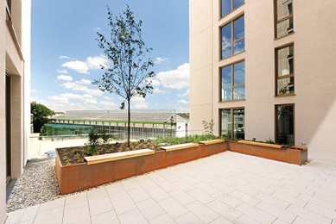 | RichardBrink_CarlsCube_02.jpg | The modern office complex has two terrace areas, which feature raised beds made from COR-TEN steel provided by the company Richard Brink.  Photo: Richard Brink GmbH & Co. KG
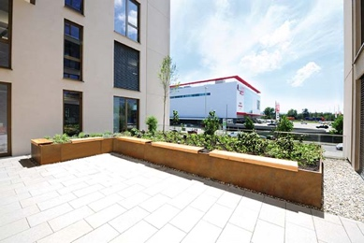 | RichardBrink_CarlsCube_03.jpg | Seating was added to one of the raised bed structures so as to make the space as enjoyable as possible for the building’s users. The front of each seat is aligned with the top of the raised bed structure.  Photo: Richard Brink GmbH & Co. KG
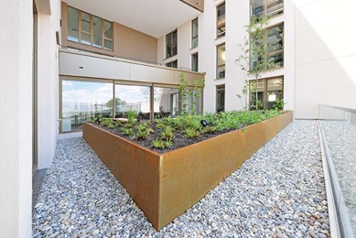 | RichardBrink_CarlsCube_04.jpg | The generously proportioned, modular plant systems were custom made and ensure maximum stability, enabling them to hold even high volumes of soil.  Photo: Richard Brink GmbH & Co. KG
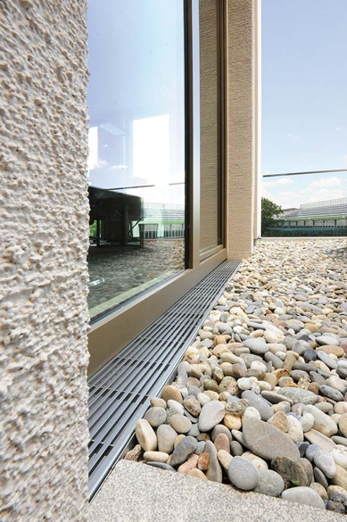 | RichardBrink_CarlsCube_05.jpg | Stainless steel Stabile drainage channels were also used, providing a reliable dewatering solution along the terraces’ glass façades.  Photo: Richard Brink GmbH & Co. KG
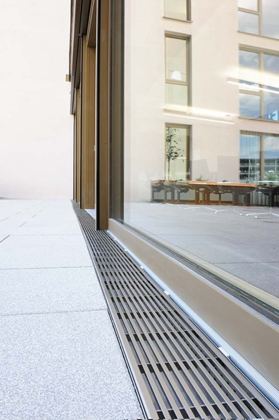 | RichardBrink_CarlsCube_06.jpg | The channels were topped with stylish, timeless longitudinal bar gratings made from stainless steel.  Photo: Richard Brink GmbH & Co. KG
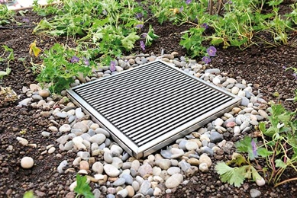 | RichardBrink_CarlsCube_07.jpg | Drainage gullies help dewater the raised beds, among other things, which are exposed to high volumes of precipitation due to their exposed location.  Photo: Richard Brink GmbH & Co. KG

