Image | File name | Caption
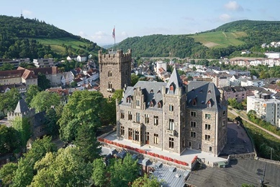 | RichardBrink_BurgKlopp_01.jpg | Klopp Castle in Bingen am Rhein is regarded as the town’s landmark and is home, among other things, to the mayor’s office and part of the municipal government.  Photo: Richard Brink GmbH & Co. KG
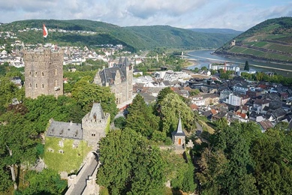 | RichardBrink_BurgKlopp_02.jpg | The castle complex sits on a hill and offers an idyllic panorama a stone’s throw from the Rhine River.  Photo: Richard Brink GmbH & Co. KG
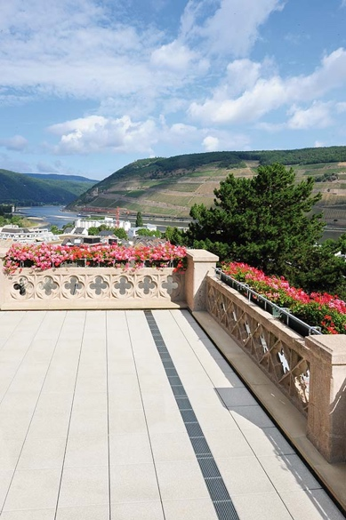 | RichardBrink_BurgKlopp_03.jpg | An approximately 222-square-metre roof terrace has been entirely refurbished in the south-east section of the castle.  Photo: Richard Brink GmbH & Co. KG
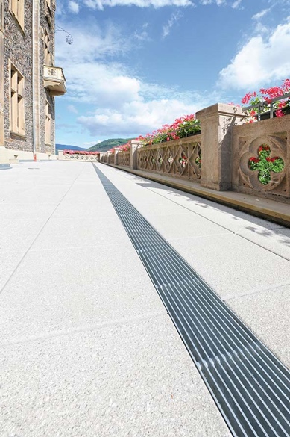 | RichardBrink_BurgKlopp_04.jpg | Large concrete paving slabs complete the newly constructed terrace area. A 16-metre-long dewatering line made up of Stabile drainage channels from the company Richard Brink systematically collects rainwater and directs it away.  Photo: Richard Brink GmbH & Co. KG
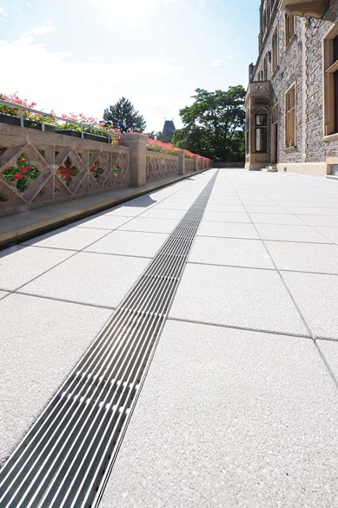 | RichardBrink_BurgKlopp_05.jpg | The drainage channels made of hot-dip galvanised steel are installed above drainage points and run in parallel with the entire length of the balustrade.  Photo: Richard Brink GmbH & Co. KG
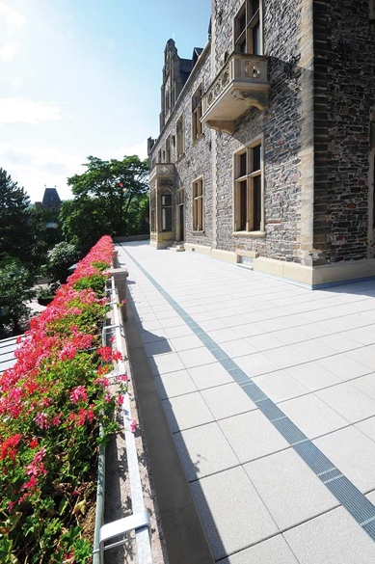 | RichardBrink_BurgKlopp_06.jpg | The channels and gratings produced by the metal products manufacturer fit perfectly with the look of the outdoor area.  Photo: Richard Brink GmbH & Co. KG
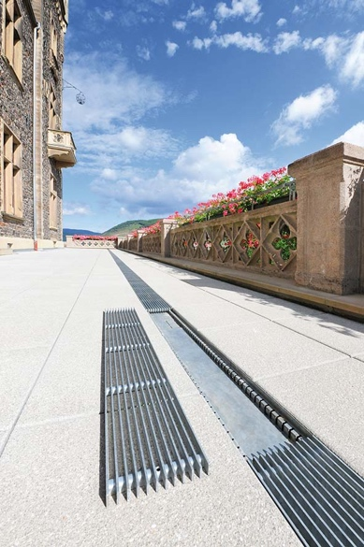 | RichardBrink_BurgKlopp_07.jpg | Longitudinal bar gratings measuring 20 x 3mm, also made of hot-dip galvanised steel, were used to cover the channel sections below.  Photo: Richard Brink GmbH & Co. KG
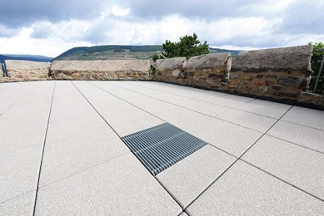 | RichardBrink_BurgKlopp_08.jpg | Hydra drainage gullies with inlet dimensions of 400 x 400mm were also installed at two points on the terrace.  Photo: Richard Brink GmbH & Co. KG

