Image | File name | Caption
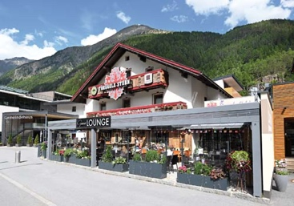 | RichardBrink_Ventus-Gastro_01 | The Modular Ventus plant boxes produced by Richard Brink not only accommodate lush greenery, they also offer privacy, protection against wind and even outdoor seating.  Photo: Richard Brink GmbH & Co. KG
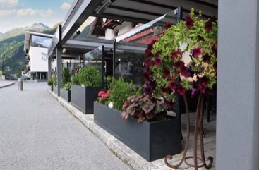 | RichardBrink_Ventus-Gastro_02 | The combination of plant box and integrated glass panel makes the product particularly suitable for outdoor dining areas in the food-service industry.  Photo: Richard Brink GmbH & Co. KG
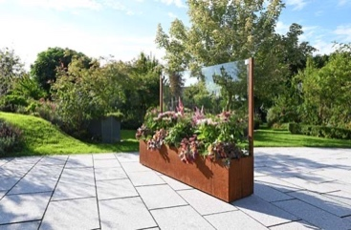 | RichardBrink_Ventus-Gastro_03 | The plant box is also available in the trend material corten steel. With its unique patina, this model adds a special charm to any outdoor space.  Photo: Richard Brink GmbH & Co. KG
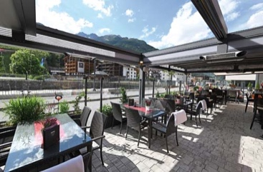 | RichardBrink_Ventus-Gastro_04 | From a dining perspective, the Modular Ventus creates structure, especially where several boxes are used together, and clearly separates seating areas from public spaces.  Photo: Richard Brink GmbH & Co. KG
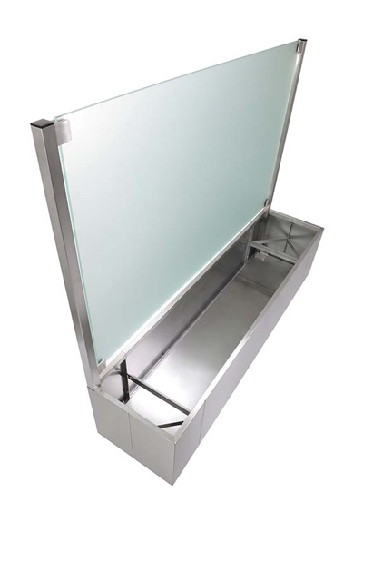 | RichardBrink_Ventus-Gastro_05 | By opting for a satin-glass panel, the product also functions as a privacy screen. This can be enhanced with appropriate greenery, for which there is ample space in the plant box itself.  Photo: Richard Brink GmbH & Co. KG
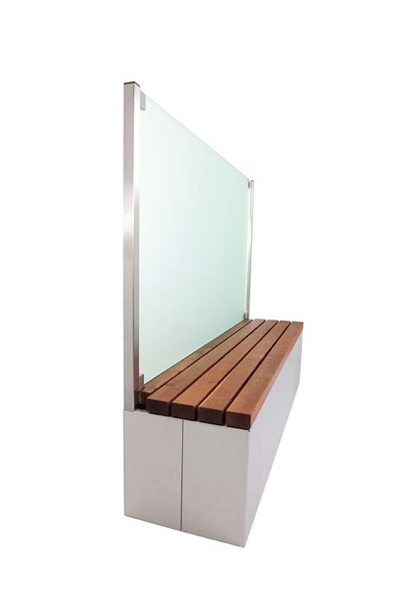 | RichardBrink_Ventus-Gastro_06 | Rather than having the box planted, the Modular Ventus can alternatively be fitted with a high-quality seat made of wood.  Photo: Richard Brink GmbH & Co. KG
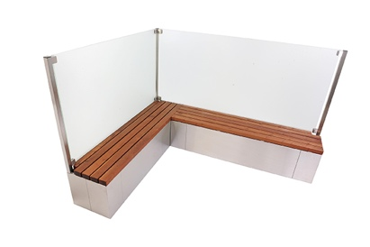 | RichardBrink_Ventus-Gastro_07 | The individual modules can easily be expanded to form a row or corner element. This allows entire seating and relaxation areas to be individually assembled.  Photo: Richard Brink GmbH & Co. KG

