Image | File name | Caption
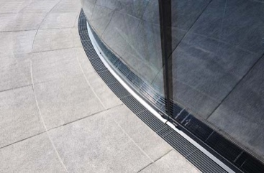 | RichardBrink_Sonderbau_01 | Alongside its broad range of standard products, the company Richard Brink also provides custom solutions for all its product groups, such as the curved drainage channels shown here.  Photo: Richard Brink GmbH & Co. KG
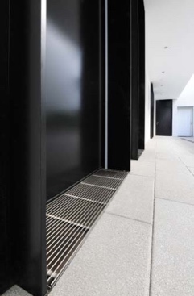 | RichardBrink_Sonderbau_02 | The metal products manufacturer from Eastern Westphalia often receives requests for custom dewatering systems made to fit specific reveal dimensions.  Photo: Richard Brink GmbH & Co. KG
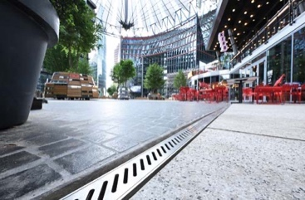 | RichardBrink_Sonderbau_03 | Beyond the standard product portfolio, custom solutions can also be designed from scratch for projects of a certain size, as was the case with the channels for the Center am Potsdamer Platz in Berlin, which ran a total of 2.7km.  Photo: Richard Brink GmbH & Co. KG
 | RichardBrink_Sonderbau_04 | In other product groups, some articles such as the Semira raised beds are available exclusively as a (configurable) custom design, with every product being one of a kind.  Photo: Richard Brink GmbH & Co. KG
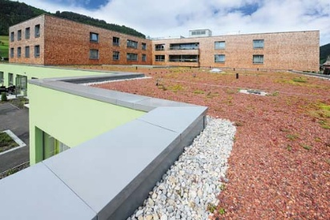 | RichardBrink_Sonderbau_05 | Similarly, the Cavor parapet coverings are produced exclusively in accordance with project-specific requirements.  Photo: Richard Brink GmbH & Co. KG

