Image | File name | Caption
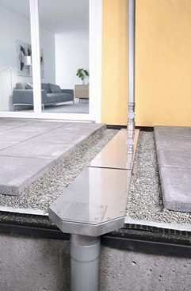 | RichardBrink_Kaskadenentwässerung_01 | Richard Brink presents its new solution, designed to achieve flexible and reliable cascade drainage. Here you can see the various elements that make up the overall system, from the inward-flow adapter to the shallow channels right over to the outward-flow adapter and subsequent downpipe.  Photo: Richard Brink GmbH & Co. KG
 | RichardBrink_Kaskadenentwässerung_02 | Accumulating precipitation is channelled through adapters attached to the rainwater pipe before entering a shallow channel system. A supplied EPDM strip is first affixed to the entire circumference of an adapter before it is connected to the shallow channel.  Photo: Richard Brink GmbH & Co. KG
 | RichardBrink_Kaskadenentwässerung_03 | This very same work step is then repeated around the end of the respective shallow channel.  Photo: Richard Brink GmbH & Co. KG
 | RichardBrink_Kaskadenentwässerung_04 | The individual elements are joined together with the help of two-part connectors, which are screwed in place. First, the lower part is laid in such a way that its centre sits beneath the point where the adapter meets the shallow channel.  Photo: Richard Brink GmbH & Co. KG
 | RichardBrink_Kaskadenentwässerung_05 | Next, the upper part of the connector is placed on top. The connector thus wraps around the ends of the connecting pieces with plenty of overlap.  Photo: Richard Brink GmbH & Co. KG
 | RichardBrink_Kaskadenentwässerung_06 | To finish, the connector is simply fixed in place using socket head screws for long-lasting installation.  Photo: Richard Brink GmbH & Co. KG
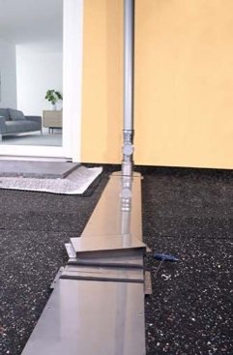 | RichardBrink_Kaskadenentwässerung_07 | These work steps are simply repeated to connect two shallow channels. To make laying the cascade solution more flexible, the system is supplied not only with straight connectors, but also with special corner connectors featuring a 45° angle.  Photo: Richard Brink GmbH & Co. KG
 | RichardBrink_Kaskadenentwässerung_08 | Before an adapter can hold a rainwater pipe or standpipe, it is first fitted with a seal.  Photo: Richard Brink GmbH & Co. KG
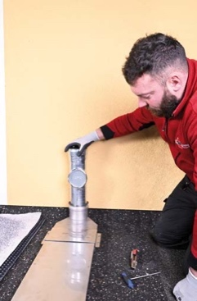 | RichardBrink_Kaskadenentwässerung_09 | The pipe can then be fixed in place. In this case, a standpipe with an integrated cleanout is used.  Photo: Richard Brink GmbH & Co. KG
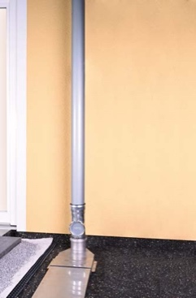 | RichardBrink_Kaskadenentwässerung_10 | The connection between the standpipe and the downpipe completes the installation on the inward-flow side of the cascade drainage system. The end of the shallow-channel line can be connected to a siphon on the roof surface or to another downpipe.  Photo: Richard Brink GmbH & Co. KG
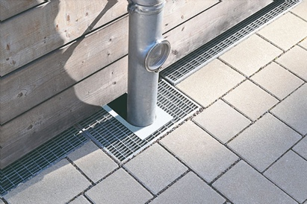 | RichardBrink_Kaskadenentwässerung_11 | It goes without saying that the new product is compatible with the other drainage and dewatering solutions provided by the metal products manufacturer – for instance, to direct the precipitation flowing out of the downpipe at ground level via channels or gullies.  Photo: Richard Brink GmbH & Co. KG
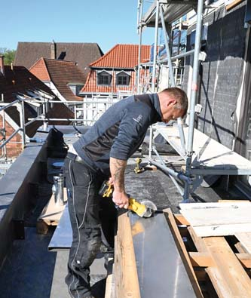  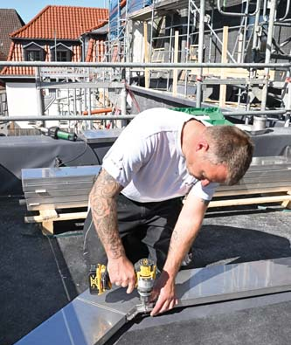 | RichardBrink_Kaskadenentwässerung_12a  RichardBrink_Kaskadenentwässerung_12b | With its cascade drainage, the company Richard Brink offers a solution that is incredibly convenient for use on construction sites thanks to its flexibility and ease of use.  Not only can it be custom cut to size (12a), it can also be used to create a line of shallow channels that is entirely in keeping with your project specifications (12b).  Photos: Richard Brink GmbH & Co. KG
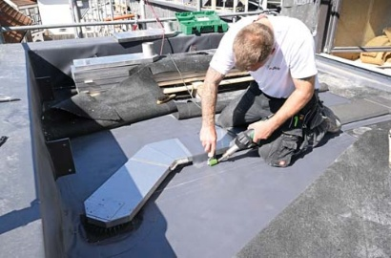 | RichardBrink_Kaskadenentwässerung_13 | The shallow channels always sit above the waterproofing layer and, thanks to their low height, can be easily and invisibly integrated into installation locations such as gravel fills and Bangkirai flooring.  Photo: Richard Brink GmbH & Co. KG

