Image | File name | Caption
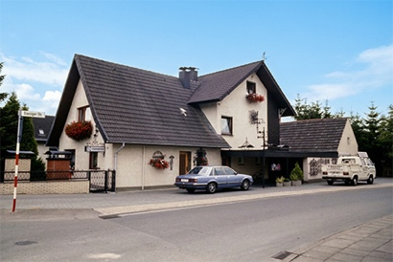 | RichardBrink_Jubiläum_01 | Richard Brink celebrates 50 years of business in 2026. Its story began in Schloss Holte-Stukenbrock back in 1976, in the garage attached to the family home.  Photo: Richard Brink GmbH & Co. KG
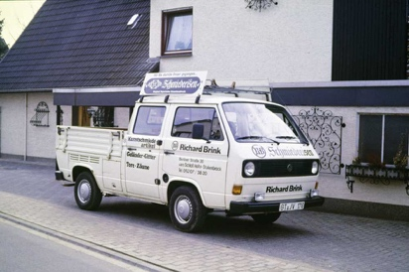 | RichardBrink_Jubiläum_02 | Back then, founder Richard Brink would drive goods out to his customers in person using the company’s first vehicle.  Photo: Richard Brink GmbH & Co. KG
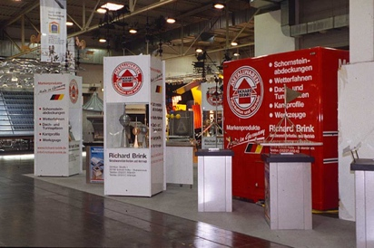 | RichardBrink_Jubiläum_03 | The metal products manufacturer from Eastern Westphalia made a name for itself within the industry partly through its presence at trade fairs, the first being Stuttgart’s Dach+Wand in 1989.  Photo: Richard Brink GmbH & Co. KG
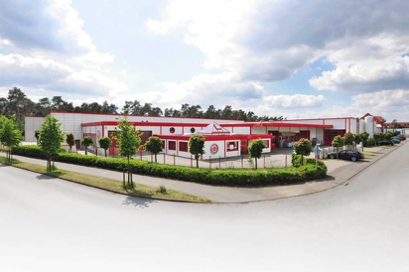 | RichardBrink_Jubiläum_04 | Ten years after being founded, the company rented its first industrial hall for the production of wrought iron products and chimney caps; after 20 years it moved into what is now the company headquarters on Görlitzer Strasse.  Photo: Richard Brink GmbH & Co. KG
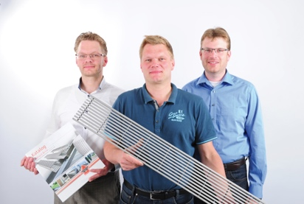 | RichardBrink_Jubiläum_05 | The first decade of the new millennium took the family-run company in a completely new direction: Sebastian, Matthias and Stefan Brink (f.l.t.r.) took over management of the company in 2007.  Photo: Richard Brink GmbH & Co. KG
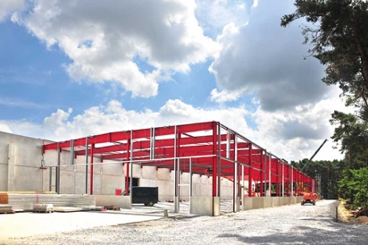 | RichardBrink_Jubiläum_06 | The company has been shaped by growth ever since: with the continuous expansion of its product range came the need to also constantly develop its operating spaces.  Photo: Richard Brink GmbH & Co. KG
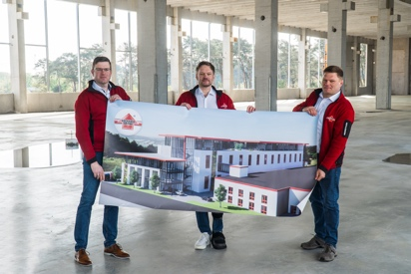 | RichardBrink_Jubiläum_07 | The highlight of this expansion to date was the two-storey production hall and warehouse with adjoining office wing, which was put into operation in 2025.  Photo: Richard Brink GmbH & Co. KG
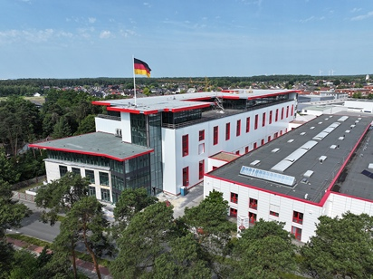 | RichardBrink_Jubiläum_08 | The new build was completed just in time for the company’s anniversary. The landmark structure looks out over the town’s rooftops and is also clearly visible from the surrounding hills of Teutoburg Forest.  Photo: Richard Brink GmbH & Co. KG
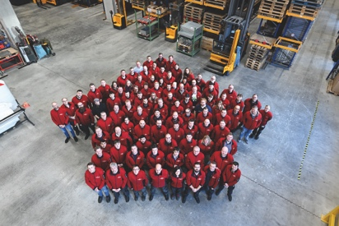 | RichardBrink_Jubiläum_09 | Despite its dynamic growth, it will always be important to Richard Brink to never lose sight of its roots, a value that reflects the down-to-earth nature typical of Eastern Westphalia. This mantra also rings true for the company’s 160 members of staff.  Photo: Richard Brink GmbH & Co. KG

