Image | File name | Caption
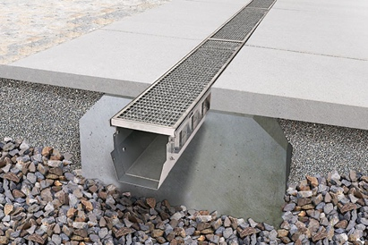 | RichardBrink_FerroMagna_01 | The Ferro Magna heavy-duty dewatering channel from the company Richard Brink appeals with its low weight while still offering maximum impact resistance and stability – before, during and after installation.  Photo: Richard Brink GmbH & Co. KG
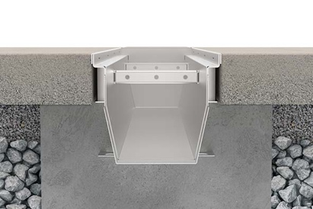 | RichardBrink_FerroMagna_02a | The channel’s design is essentially composed of support profiles and casing troughs made entirely of metal. This results in a fully recyclable product.  Photo: Richard Brink GmbH & Co. KG
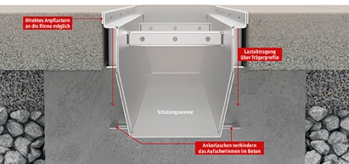 | RichardBrink_FerroMagna_02b | The support profiles safely direct excessive forces, caused for instance by vehicles in courtyards and driveways, into the foundation. What’s more, paving stones can be laid right up to the channel edge. Integrated concrete anchors make sure that the Ferro Magna is unable to lift up out of place when the foundation is poured.  Photo: Richard Brink GmbH & Co. KG
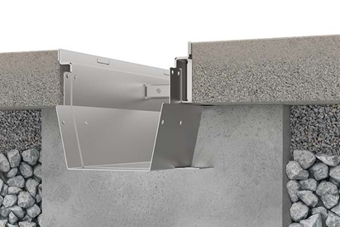 | RichardBrink_FerroMagna_03 | While frequently used concrete channels are prone to damage during transport, installation and subsequent processing, the Ferro Magna impresses as a resilient alternative for every scenario.  Photo: Richard Brink GmbH & Co. KG
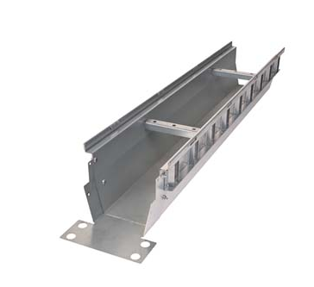 | RichardBrink_FerroMagna_04 | The metal products manufacturer from Eastern Westphalia provides its heavy-duty channel in a range of dimensions to suit the installation location and requirements. Custom measurements are also possible.  Photo: Richard Brink GmbH & Co. KG
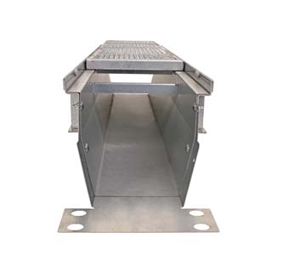 | RichardBrink_FerroMagna_05 | Compatible grating covers such as heavy-duty mesh gratings and longitudinal bar gratings also form part of the product line.  Photo: Richard Brink GmbH & Co. KG
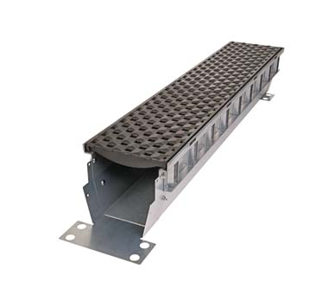 | RichardBrink_FerroMagna_06 | The cast gratings offered by Richard Brink give the channels a beautiful finish. Customers can choose from three designs at present. The model shown here is the Prisma, which was honoured with the Red Dot Design Award.  Photo: Richard Brink GmbH & Co. KG
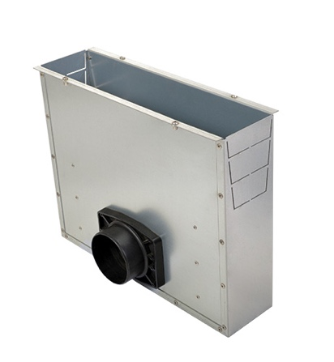 | RichardBrink_FerroMagna_07 | Corresponding end pieces and flush boxes round off the range of system components available for the Ferro Magna.  Photo: Richard Brink GmbH & Co. KG

