Image | File name | Caption
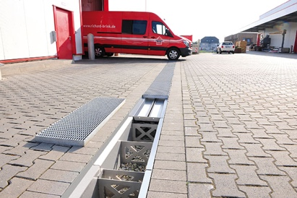 | RichardBrink_Starkregen_01 | The company Richard Brink presents its range of retention channels as a modern approach to stormwater management in times of climate change and extreme weather events.  Photo: Richard Brink GmbH & Co. KG
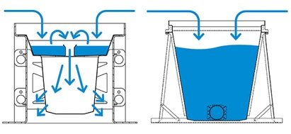 | RichardBrink_Starkregen_02 | Products comprise the RigoMax gravel-filled drainage channel (left) and the FerroMax water collection channel (right). Both offer an efficient solution that navigates two conflicting priorities: the unsealing of urban surfaces and the construction of new living space.  Photo: Richard Brink GmbH & Co. KG
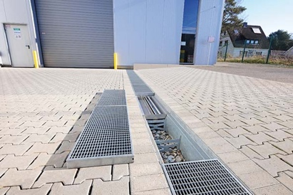 | RichardBrink_Starkregen_03 | The robust channels are made from stainless steel or hot-dip galvanised steel and meet the requirements of up to load class E 600 or a maximum wheel load of 10 tonnes. A range of grating designs are available to beautifully finish the channel.  Photo: Richard Brink GmbH & Co. KG
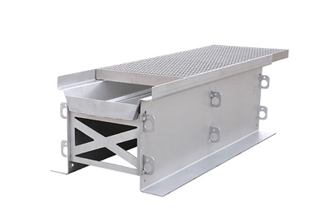 | RichardBrink_Starkregen_04 | Depending on the chosen height and width, whether standard measurements or custom dimensions on request, the 1,000mm-long channels have a holding capacity of between approximately 100 litres and over 900 litres.  Photo: Richard Brink GmbH & Co. KG
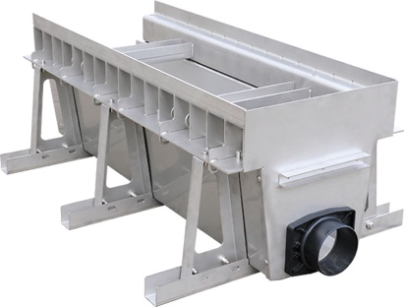 | RichardBrink_Starkregen_05 | The FerroMax is the ideal solution if the surrounding substrate is unable to drain water. Thanks to the drain nozzle measuring between DN 50 and DN 200, the water is gradually released into the sewer system. It also has base feet, which makes on-site installation easier.  Photo: Richard Brink GmbH & Co. KG
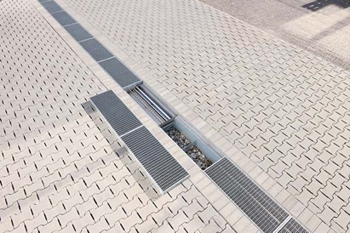 | RichardBrink_Starkregen_06 | The RigoMax is better suited to permeable substrates: its open base allows it to drain directly into the ground. The construction features a filter insert as standard, which holds back coarse dirt.  Photo: Richard Brink GmbH & Co. KG

