Image | File name | Caption
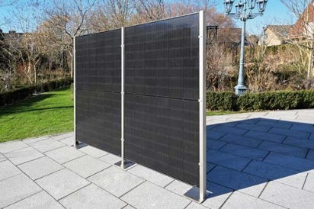 | RichardBrink_Solarzaun_01 | Richard Brink has expanded its range of products to include a new solar fence developed in-house. The panels act not only as privacy and partition elements but also as a green power source.  Photo: Richard Brink GmbH & Co. KG
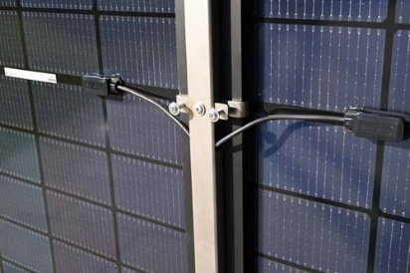 | RichardBrink_Solarzaun_02 | Stainless-steel fence posts featuring integrated cable channels as well as clamp mounts that hold the modules securely in place while preventing damage to their surface are supplied with the panels.  Photo: Richard Brink GmbH & Co. KG
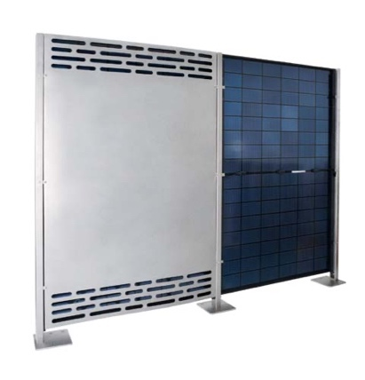 | RichardBrink_Solarzaun_03 | The metal products manufacturer from Eastern Westphalia provides tailor-made covers for the back of the panels that render the cables practically invisible and prevent heat accumulation thanks to the integrated ventilation slots.  Photo: Richard Brink GmbH & Co. KG
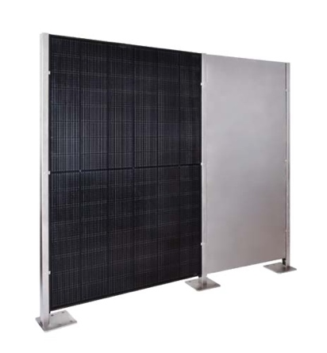 | RichardBrink_Solarzaun_04 | In order to achieve the desired fencing length on site, custom-made stainless-steel panels can also be inserted between the fence posts.  Photo: Richard Brink GmbH & Co. KG
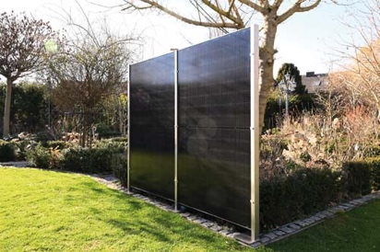 | RichardBrink_Solarzaun_05 | The modules can be fitted either vertically or horizontally, allowing for various design options and fence heights.  Photo: Richard Brink GmbH & Co. KG
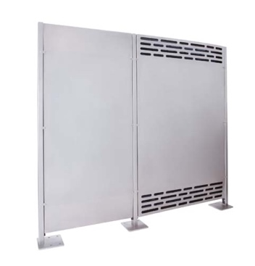 | RichardBrink_Solarzaun_06 | Richard Brink GmbH & Co. KG always provides a complete package ready for installation that comprises the posts and mounts, modules and the respective microinverters and cables.  Photo: Richard Brink GmbH & Co. KG

