Image | File name | Caption
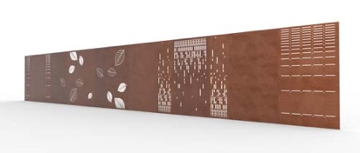 | RichardBrink_Sichtschutz_01 | The company Richard Brink has expanded its range of products to include a privacy fence developed in-house made from premium corten steel. The family-run company from Eastern Westphalia can also incorporate custom design elements on request, such as those seen here.  Photo: Richard Brink GmbH & Co. KG
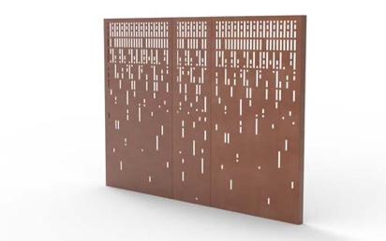 | RichardBrink_Sichtschutz_02 | The 500mm or 1,000mm-wide elements are seamlessly fixed and expanded using screwed connections located inside the backward bend.  Photo: Richard Brink GmbH & Co. KG
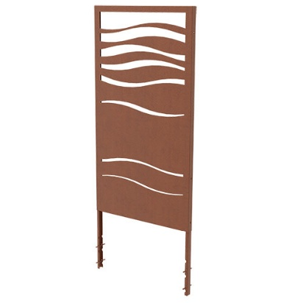 | RichardBrink_Sichtschutz_03 | Concrete anchors ensure durable ground stability. They are slotted into the backward bend and sit 550mm deep in the respective foundation.  Photo: Richard Brink GmbH & Co. KG
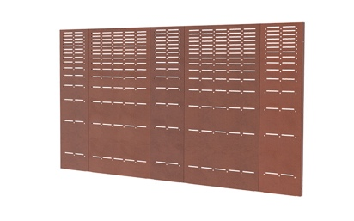 | RichardBrink_Sichtschutz_04 | The 1,800mm-high panels can either be installed unadorned, highlighting the contemporary rust finish of the 2.0mm-thick corten steel, or they can be used as decorative outdoor features by incorporating laser-cut patterns.  Photo: Richard Brink GmbH & Co. KG
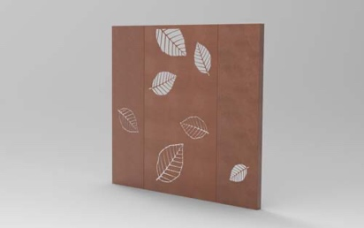 | RichardBrink_Sichtschutz_05 | In terms of visual design, customers can choose from laser-cut floral patterns or motifs based on the Ritmo, Staccato or Legato grating covers produced by the metal products manufacturer. On request, individual patterns or logos can also be integrated into the panels.  Photo: Richard Brink GmbH & Co. KG

