Image | File name | Caption
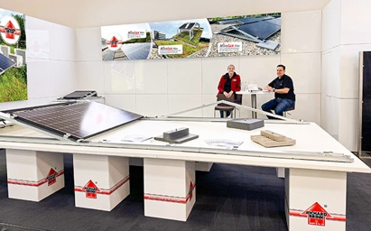 | RichardBrink_Intersolar_01 | The company Richard Brink took up stand A5.630 at the three-day Intersolar Europe 2025 in Munich, where it presented its Miralux products: a range of modular, extendable solar substructures with integrated cable channels.  Photo: Richard Brink GmbH & Co. KG
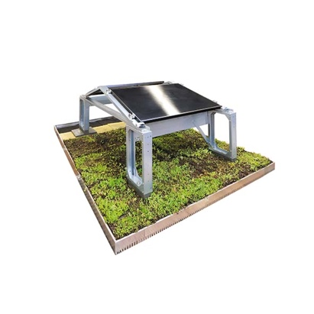 | RichardBrink_Intersolar_02 | The structures can be used for all kinds of applications in a south or an east-west orientation and can hold all commercially available panel sizes thanks to the use of flexible module clamps. The east-west version can also be affixed to a mounting system to facilitate its use on green roofs.  Photo: Richard Brink GmbH & Co. KG
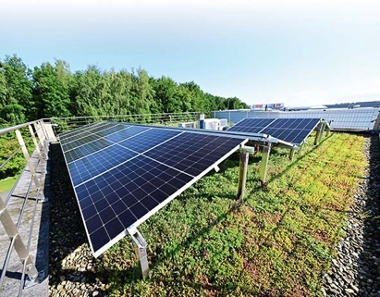 | RichardBrink_Intersolar_03 | The Miralux Green model builds on the Miralux to combine roof planting and fixing elements in one system, whereby the substrate and vegetation also function as ballast. Polymer concrete blocks developed in house are used together with building protection mats in the conventional model.  Photo: Richard Brink GmbH & Co. KG
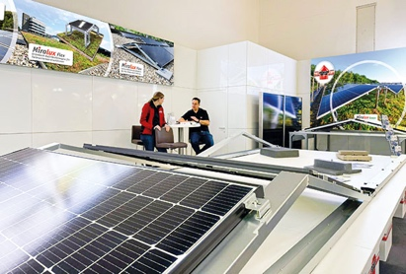 | RichardBrink_Intersolar_04 | The sophisticated system designed by Richard Brink GmbH & Co. KG saves space during transport and can be folded out without the need for tools. It is also capable of carrying lightning current and boasts a reduced distributed load, as confirmed in wind tunnel tests.  Photo: Richard Brink GmbH & Co. KG
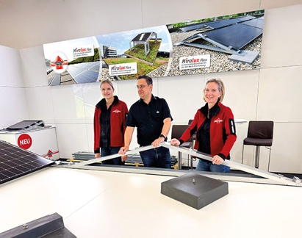 | RichardBrink_Intersolar_05 | The team representing the metal products manufacturer from Eastern Westphalia spent the three intense days speaking to customers face-to-face and holding individual consultations, with the 4-in-1 exhibition “The smarter E Europe” providing the perfect setting.  Photo: Richard Brink GmbH & Co. KG

