Image | File name | Caption
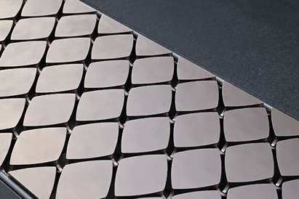 | RichardBrink_Reddot_01 | The Gemma designer grating has been honoured with the renowned Red Dot Design Award. The 2025 award marks the fourth time the jury has recognised a grating cover produced by Richard Brink and the second time it has named the company “Best of the Best”.  Photo: Richard Brink GmbH & Co. KG
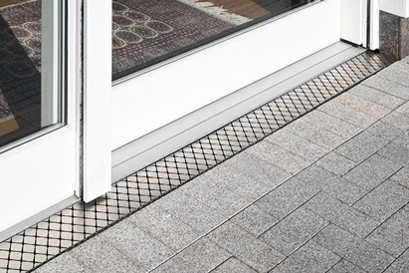 | RichardBrink_Reddot_02 | The diamond pattern with its slightly curved sides is available in either a sand-blasted matt or a brushed, glossy finish and creates unique reflections and shade in hues of grey and white as it catches the light.  Photo: Richard Brink GmbH & Co. KG
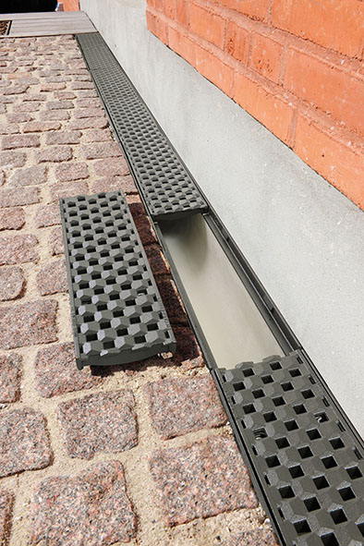 | RichardBrink_Reddot_03 | In 2019, the Prisma cast grating featuring an interwoven, bevelled design came out on top in the Urban Design category, with the jury remarking that its harmonious look “accentuates a slick urban aesthetic”.  Photo: Richard Brink GmbH & Co. KG
 | RichardBrink_Reddot_04 | Double-slit grating Gemini, named after the Latin for twin, was also honoured with the Best of the Best title in 2015. Thanks to its integrated stone tray, it blends discreetly into any paved surface.  Photo: Richard Brink GmbH & Co. KG
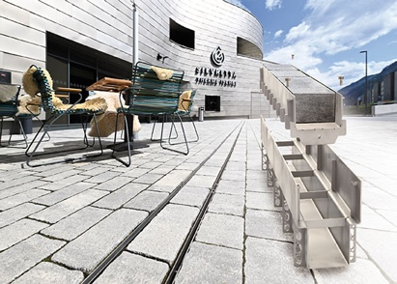 | RichardBrink_Reddot_05 | Also in the heavy-duty version Gemini Magna, the channel brings together the advantages of a box and a slotted construction in a purist design. The development over the years attests to the fact that functionality and aesthetics always go hand in hand at Richard Brink GmbH & Co. KG.  Photo: Richard Brink GmbH & Co. KG
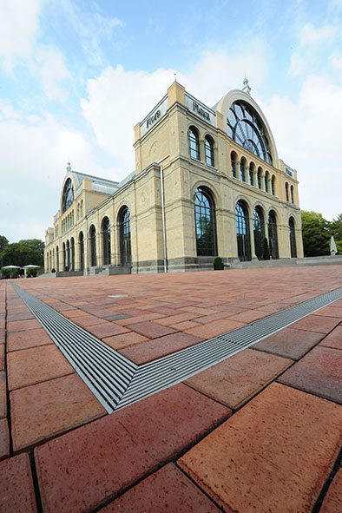 | RichardBrink_Reddot_06 | Back in 2010, the Hydra Linearis longitudinal bar grating was the first product made by the metal products manufacturer based in Eastern Westphalia to receive the Red Dot Design Award. The premium stainless-steel bars measuring 7x7mm create an elegant look along the product’s entire length.  Photo: Richard Brink GmbH & Co. KG
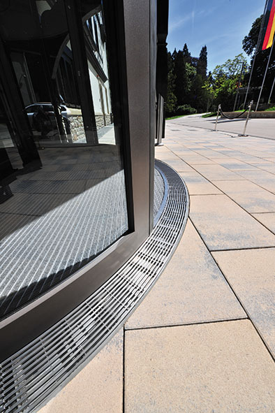 | RichardBrink_Reddot_07 | The grating is also available as a curved and a heavy-duty version. The four completely different designs distinguished by the jury testify to the high standards and diversity of product development found at Richard Brink.  Photo: Richard Brink GmbH & Co. KG

