Image | File name | Caption
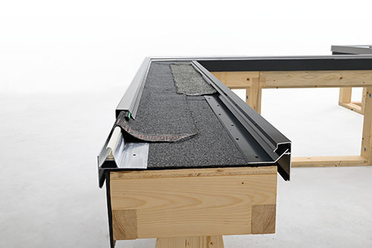 | RichardBrink_Dachrandabschlussprofil_01 | Two new aluminium roof edge cover profiles – Nexum (left) and Conar (right) – are the latest addition to Richard Brink’s range of products for roof and wall systems.  Photo: Richard Brink GmbH & Co. KG
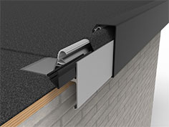 | RichardBrink_Dachrandabschlussprofil_02 | Both versions are available in a standard length of 3,000mm and various heights between 100mm and 200mm. Optional coating in any RAL colour helps create the perfect look. The three-part Nexum variant is depicted here.  Photo: Richard Brink GmbH & Co. KG
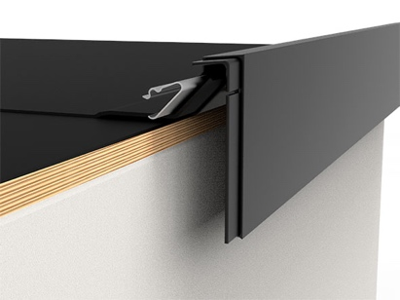 | RichardBrink_Dachrandabschlussprofil_03 | Common to both variants are features such as water impermeability and wind resilience, and both are designed for sealing films up to 5mm thick or bituminous sheeting with no more than two overlapping layers and a maximum thickness of 10mm. The two-part Conar variant is depicted here.  Photo: Richard Brink GmbH & Co. KG
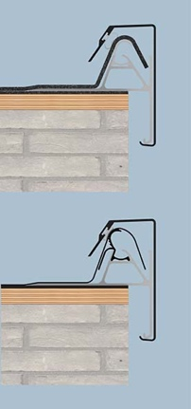 | RichardBrink_Dachrandabschlussprofil_04 | Nexum has a three-piece construction consisting of a base profile, a fixing element and a trim. By screwing the fixing element to the roof edge, the roof is sealed before the trims are finally attached.  Photo: Richard Brink GmbH & Co. KG
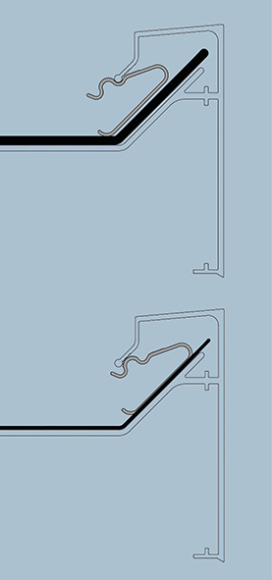 | RichardBrink_Dachrandabschlussprofil_05 | Conar, on the other hand, uses two pieces to protect the roof edge and the transition to the façade from moisture and precipitation. Here, the base profile and trim are manufactured as a single piece.  Photo: Richard Brink GmbH & Co. KG
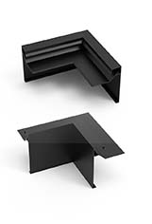 | RichardBrink_Dachrandabschlussprofil_06 | Matching accessories such as internal and external corners plus connecting and end pieces complete the product range. As a result, the metal products manufacturer from Eastern Westphalia can supply an installation-ready full package tailored to the specific project at any time.  Photo: Richard Brink GmbH & Co. KG

