Image | File name | Caption
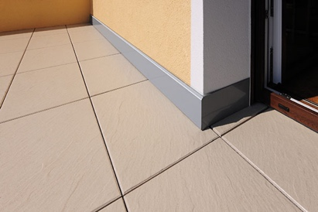 | RichardBrink_BasisClip_01 | Alongside its classic screw-in wall connection profiles, Richard Brink also offers an alternative model with a snap-fit mount.  Photo: Richard Brink GmbH & Co. KG
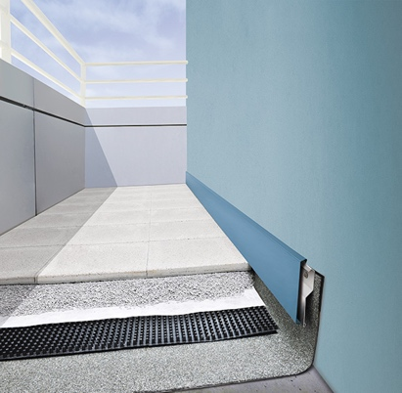 | RichardBrink_BasisClip_02 | The Basis Clip profile is made of 1.5mm-thick aluminium with a height of 150mm as standard. It has a two-part construction: the guide profile acts as a base and is screwed directly onto the wall, while the visible part of the profile fits over the top and covers the base without any visible fixtures.  Photo: Richard Brink GmbH & Co. KG
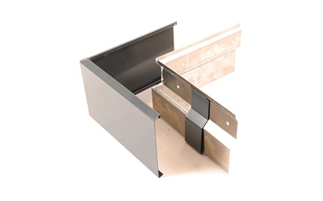 | RichardBrink_BasisClip_03 | Richard Brink also offers additional components such as connector, corner and end pieces to fit the wall connection profiles, which can be made to measure on request.  Photo: Richard Brink GmbH & Co. KG
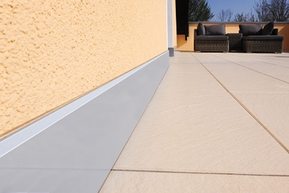 | RichardBrink_BasisClip_04 | As with the conventional Basis model, the upper joint is sealed with silicone after the profile has been fitted, concealing the transition from floor to wall for an appealing and also functional finish.  Photo: Richard Brink GmbH & Co. KG

