Image | File name | Caption
 | RichardBrink_Atrium-2025_01 | With its Atrium shower tray, the company Richard Brink satisfies the highest standards when it comes to creating modern shower areas.  Photo: Richard Brink GmbH & Co. KG
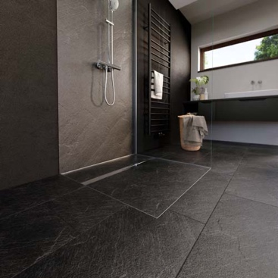 | RichardBrink_Atrium-2025_02 | The integrated system produces a barrier-free shower that lends itself to a variety of styles and finishes thanks to the tile-over shower tray.  Photo: Richard Brink GmbH & Co. KG
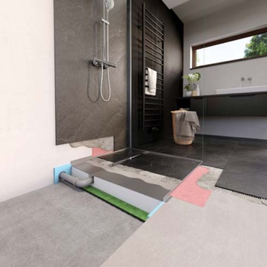 | RichardBrink_Atrium-2025_03 | The product comprises a sound insulation mat, a two-part XPS substructure complete with siphon and a sanded stainless-steel tray with compatible sealing tapes.  Photo: Richard Brink GmbH & Co. KG
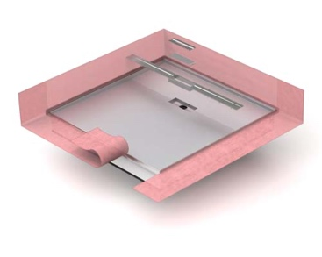 | RichardBrink_Atrium-2025_04 | The shower tray features a prefabricated raised edge along all sides that aids the transition from tray to floor and wall.  Photo: Richard Brink GmbH & Co. KG
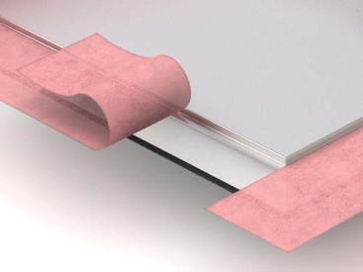 | RichardBrink_Atrium-2025_05 | The sealing tapes form part of the standard scope of delivery and, on request, can be affixed to the tray during production.  Photo: Richard Brink GmbH & Co. KG
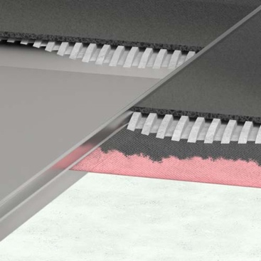 | RichardBrink_Atrium-2025_06 | The system can either be placed into a recess in the screed or positioned on the floor before the screed is laid. The tiles are laid right up to the edge, which makes for a virtually seamless finish.  Photo: Richard Brink GmbH & Co. KG
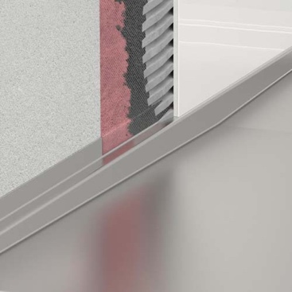 | RichardBrink_Atrium-2025_07 | The transition to the wall areas is also entirely watertight thanks to the tray’s surrounding edges and sealing tapes.  Photo: Richard Brink GmbH & Co. KG
 | RichardBrink_Atrium-2025_08 | The Atrium’s stainless-steel tray always features a gradient, which eliminates the need to create one during installation.  Photo: Richard Brink GmbH & Co. KG
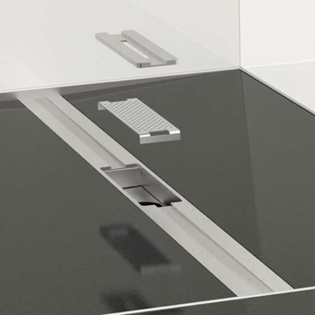 | RichardBrink_Atrium-2025_09 | An insertable draining channel made from polished stainless steel also forms part of the complete package. The channel includes a removable insert complete with hair catcher for easier cleaning.  Photo: Richard Brink GmbH & Co. KG
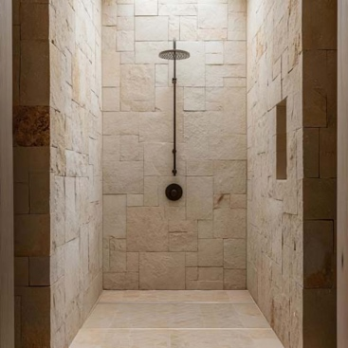 | RichardBrink_Atrium-2025_10 | Regardless of design concept – the Atrium shower tray always caters to the customer’s individual preferences while ensuring the highest level of functionality, precision and watertightness.  Photo: Richard Brink GmbH & Co. KG

