Image | File name | Caption
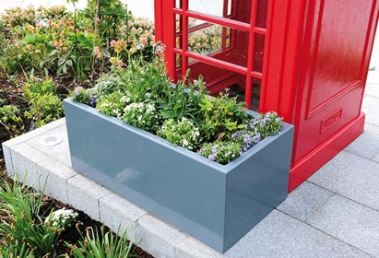 | RichardBrink_Clarus_01 | The Clarus from Richard Brink is the latest in the company’s plant box range and features seamless welded joints and is highly customisable.  Photo: Richard Brink GmbH & Co. KG
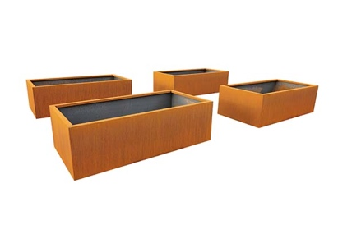 | RichardBrink_Clarus_02 | The plant box is a bespoke addition to a range from the metal products manufacturer that includes the Basio model.  Photo: Richard Brink GmbH & Co. KG
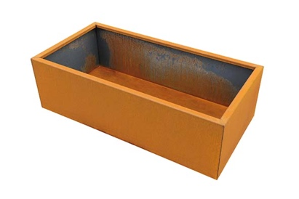 | RichardBrink_Clarus_03 | All Clarus units are tailor-made to the customer’s requirements and its dimensions can be adapted to the specifications of the individual project.  Photo: Richard Brink GmbH & Co. KG
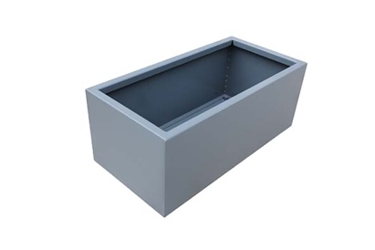 | RichardBrink_Clarus_04 | Richard Brink manufactures the monolithic plant box with no visible weld seams from corten steel, stainless steel or coated aluminium from a thickness of 3mm.  Photo: Richard Brink GmbH & Co. KG
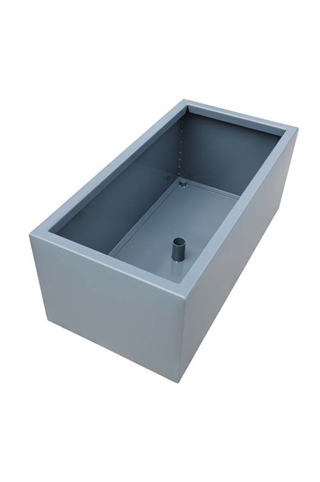 | RichardBrink_Clarus_05 | An internal nozzle in the base panel guarantees the controlled drainage of excess irrigation water or precipitation.  Photo: Richard Brink GmbH & Co. KG

