Image | File name | Caption
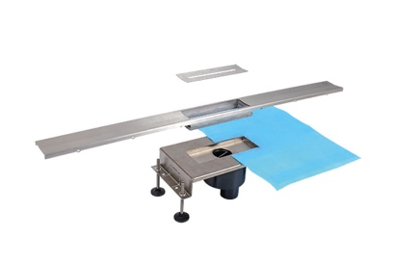 | RichardBrink_SecaCentralis_01 | The Seca shower-channel system consists of a stainless-steel drain body complete with nozzle and siphon as well as a channel profile that utilises an insertable attachment.  Photo: Richard Brink GmbH & Co. KG
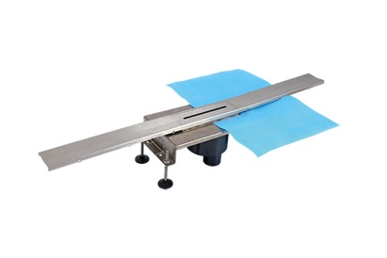 | RichardBrink_SecaCentralis_02 | The new product is factory-fitted with an extensive sealing collar and can also be easily adapted to any installation situation thanks to the height-adjustable articulated feet.  Photo: Richard Brink GmbH & Co. KG
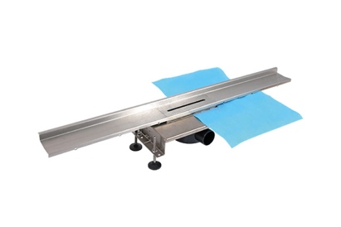 | RichardBrink_SecaCentralis_03 | The drain bodies can be supplied for a central or, as illustrated here, a wall-side connection. The channel profiles themselves can be cut to the required length.  Photo: Richard Brink GmbH & Co. KG
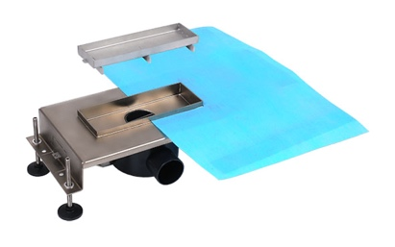 | RichardBrink_SecaCentralis_04 | The Centralis point drainage unit is a single-part drain body made from stainless steel with a central tiled tray.  Photo: Richard Brink GmbH & Co. KG
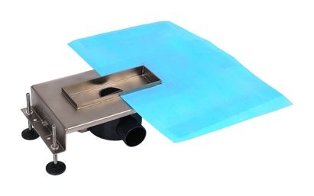 | RichardBrink_SecaCentralis_05 | This new product also comes with a sealing collar and height-adjustable articulated feet as standard.  Photo: Richard Brink GmbH & Co. KG
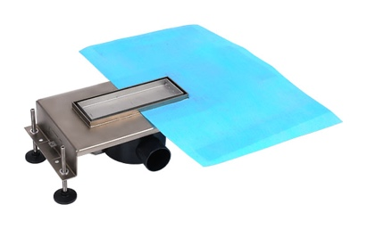 | RichardBrink_SecaCentralis_06 | Tiles can be laid right up to the edge of the tiled tray base during installation, creating an exceptionally minimalistic aesthetic in the shower area.  Photo: Richard Brink GmbH & Co. KG

