Image | File name | Caption
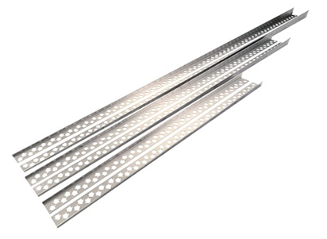 | RichardBrink_DUKEP_01 | The new stainless-steel gradient wedges from Richard Brink GmbH & Co. KG create an attractive and reinforced transition between the built-up sloping screed and the surrounding horizontal tiled surface for floor-level showers.  Photo: Richard Brink GmbH & Co. KG
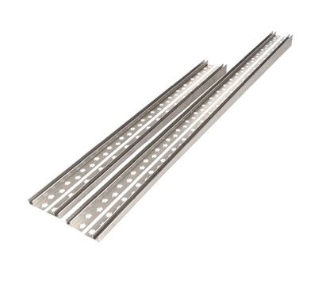 | RichardBrink_DUKEP_02 | The metal products manufacturer also offers profiles with a glass groove for glass panels with a thickness of up to 12mm.  Photo: Richard Brink GmbH & Co. KG
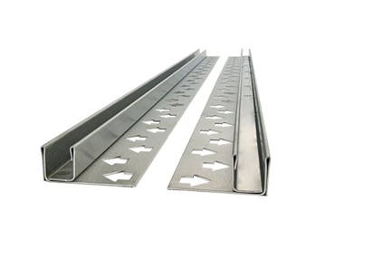 | RichardBrink_DUKEP_03 | The range includes additional product variants with a glass groove in the wall area. These can be supplied as a complete set along with the accompanying floor profiles, enabling the glass elements to be securely anchored both horizontally and vertically.  Photo: Richard Brink GmbH & Co. KG
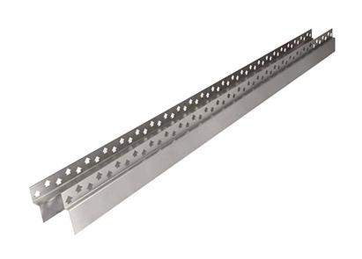 | RichardBrink_DUKEP_04 | Matching end profiles for the front side of the wall areas complete the range from Richard Brink.  Photo: Richard Brink GmbH & Co. KG
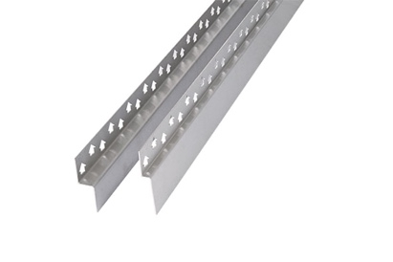 | RichardBrink_DUKEP_05 | The end profiles create a harmonious look with an all-round stainless-steel look which perfectly complements the gradient wedges.  Photo: Richard Brink GmbH & Co. KG

