Image | File name | Caption
 | RichardBrink_Neuheiten_01 | The drain mat adapter from Richard Brink is the perfect addition to the Hydra drainage channel and makes drain mats even easier to lay.  Photo: Richard Brink GmbH & Co. KG
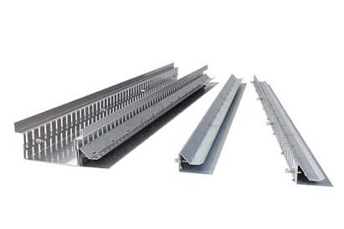 | RichardBrink_Neuheiten_02 | The first step is to fix the adapter, which is specifically manufactured to fit the channel, to the channel body using the screws supplied. Two adapter variants are available to fit mats with a thickness of 8mm or 16mm.  Photo: Richard Brink GmbH & Co. KG
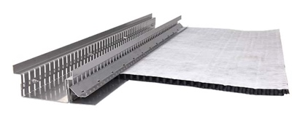 | RichardBrink_Neuheiten_03 | The mat is then pushed into the adapter slot and seamlessly attached to the channel using small barbs.  Photo: Richard Brink GmbH & Co. KG
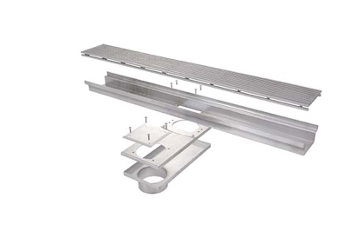 | RichardBrink_Neuheiten_04 | The metal products manufacturer supplies a reveal drain that enables reveal zones to be easily bridged if a direct connection to the channel is not possible.  Photo: Richard Brink GmbH & Co. KG
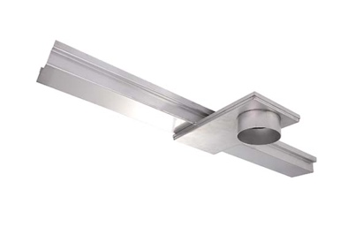 | RichardBrink_Neuheiten_05 | The drain is attached below the channel and is designed to be connected outside the reveal zone. The unit is also accessible for inspection purposes.  Photo: Richard Brink GmbH & Co. KG
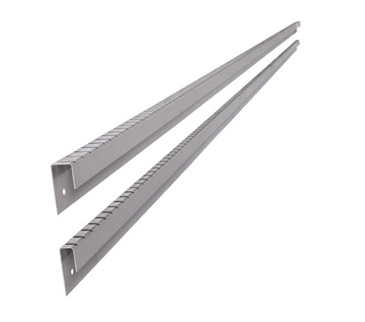 | RichardBrink_Neuheiten_06 | The new dimpled sheet cover track creates a clean, straight exposed metal edge on rising surfaces.  Photo: Richard Brink GmbH & Co. KG

