Image | File name | Caption
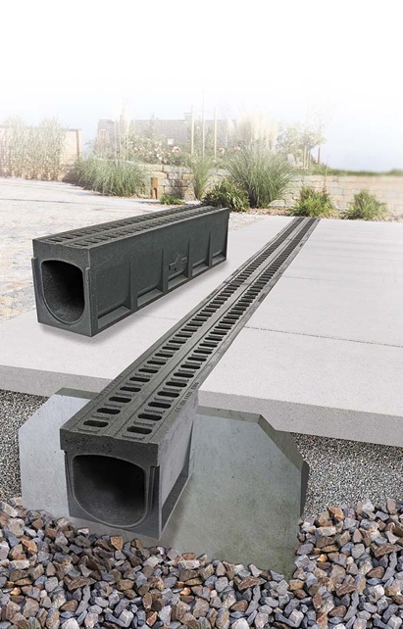 | RichardBrink_MonoFortis_01 | The Mono-Fortis dewatering channel from the company Richard Brink is the ideal solution for heavy-duty use up to load class E 600.  Photo: Richard Brink GmbH & Co. KG
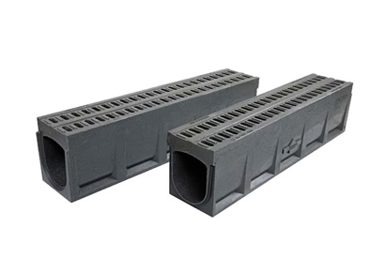 | RichardBrink_MonoFortis_02 | The new polymer concrete product from the metal products manufacturer combines the channel body and grating in one monolithic component. A nut-and-groove system with integrated rubber seals ensures a watertight transition at the channel joints.  Photo: Richard Brink GmbH & Co. KG
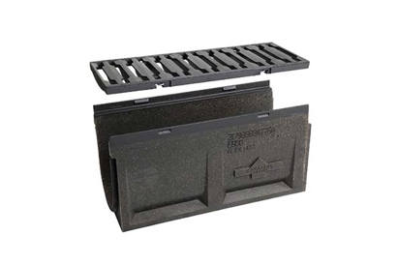 | RichardBrink_MonoFortis_03 | Half-metre lengths of the Poly-Fortis channels topped with the Zippa grating can be used as a flush box.  Photo: Richard Brink GmbH & Co. KG
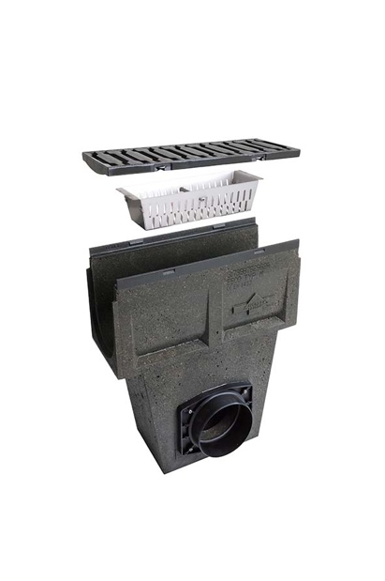 | RichardBrink_MonoFortis_04 | The Mono-Fortis can also be combined with drainage units made from polymer concrete that feature dirt traps and can be connected to the sewer system.  Photo: Richard Brink GmbH & Co. KG
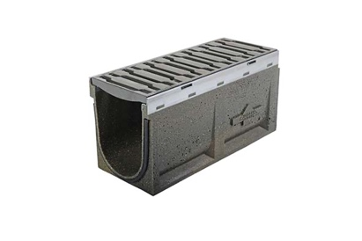 | RichardBrink_MonoFortis_05 | For both the flush box and drainage unit used with the Mono-Fortis, customers can choose between frames made from cast iron or hot-dip galvanised steel.  Photo: Richard Brink GmbH & Co. KG
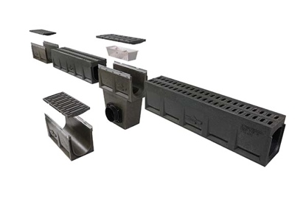 | RichardBrink_MonoFortis_06 | The flexible combination of the Mono-Fortis with flush boxes and drainage units allows for all kinds of options when putting together functional and extremely robust linear drainage.  Photo: Richard Brink GmbH & Co. KG

