Image | File name | Caption
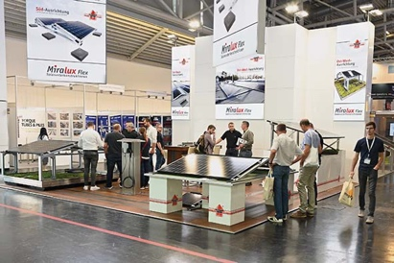 | RichardBrink_Intersolar2023_01 | The company Richard Brink presented its diverse range of solar substructures at the Intersolar Europe 2023 in Munich.  Photo: Richard Brink GmbH & Co. KG
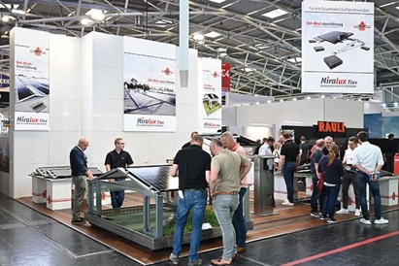 | RichardBrink_Intersolar2023_02 | Interested visitors could take a look at the time-proven solutions for east-west and south-facing installations and also see two brand new products at the well-frequented exhibition stand.  Photo: Richard Brink GmbH & Co. KG
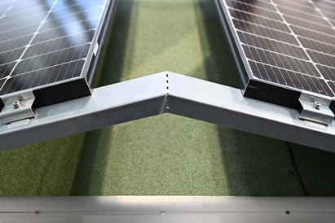 | RichardBrink_Intersolar2023_03 | The substructures produced by the metal products manufacturer, such as the Miralux Flex in the east-west version seen here, appeal with their ease of use thanks to their tool-free assembly.  Photo: Richard Brink GmbH & Co. KG
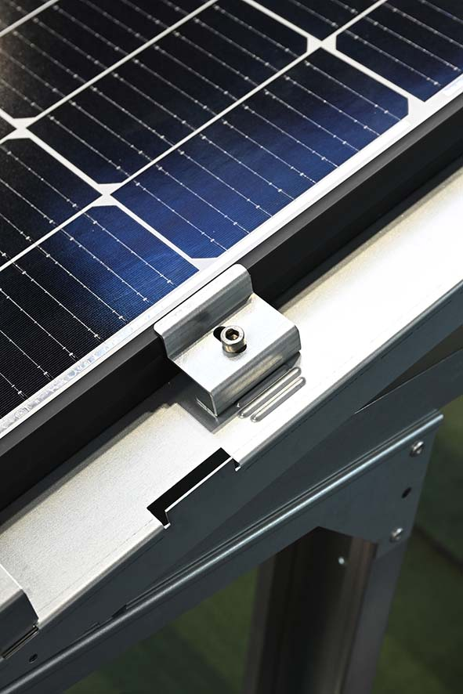 | RichardBrink_Intersolar2023_04 | Richard Brink now includes flexible module clamps as standard with the Miralux Flex solar substructures, allowing all kinds of commercially available panel sizes to be fitted and adjusted, irrelevant of module manufacturer.  Photo: Richard Brink GmbH & Co. KG
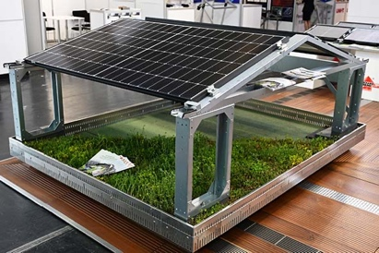 | RichardBrink_Intersolar2023_05 | The green-roof mounting systems, which expand the product portfolio for east-west-facing installations, attracted a lot of interest. They allow green roofs to be combined with photovoltaics – for existing green roofs and for new builds.  Photo: Richard Brink GmbH & Co. KG
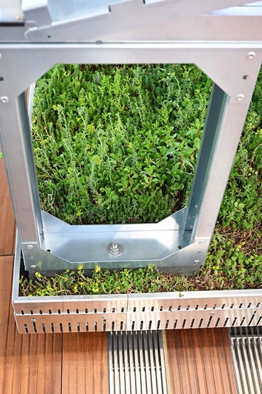 | RichardBrink_Intersolar2023_06 | The mounting system is secured directly under the substructure. Additional ballast blocks feature a raised section that can be screwed to the base of the substructure; the blocks are then subtly incorporated into the layer of planting.  Photo: Richard Brink GmbH & Co. KG
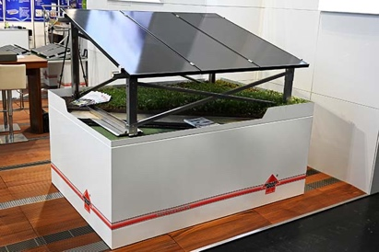 | RichardBrink_Intersolar2023_07 | The new Miralux Green system for new builds unites green roof and substructure in one solid system.  Photo: Richard Brink GmbH & Co. KG
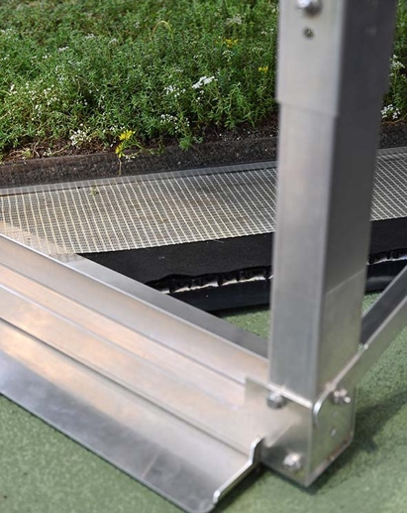 | RichardBrink_Intersolar2023_08 | Thanks to the use of supporting bases and all-over glass fibre mesh, the roof planting also provides ballast for the solar substructure.  Photo: Richard Brink GmbH & Co. KG
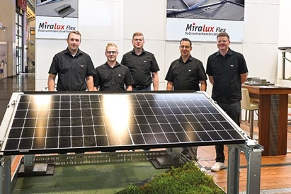 | RichardBrink_Intersolar2023_09 | Over the course of the three-day event, the Richard Brink team were on hand to help and advise the international trade visitors. The trade fair offered a perfect setting for individual consultations and face-to-face conversations at the stand.  Photo: Richard Brink GmbH & Co. KG

