Image | File name | Caption
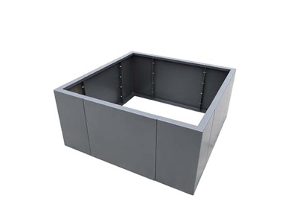 | RichardBrink_HochbeetModular_01 | The new Modular raised beds from the company Richard Brink continue the eponymous plant box design into the raised bed segment.  Photo: Richard Brink GmbH & Co. KG
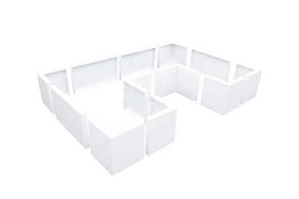 | RichardBrink_HochbeetModular_02 | The system consists of rectangular elements in three different lengths as well as compatible corner pieces. Customers can choose between a height of 380mm or 600mm.  Photo: Richard Brink GmbH & Co. KG
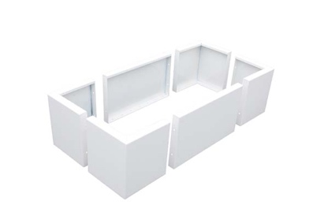 | RichardBrink_HochbeetModular_03 | All kinds of shapes and dimensions can be created thanks to the bed’s modular construction and flexible choice of walls and corners.  Photo: Richard Brink GmbH & Co. KG
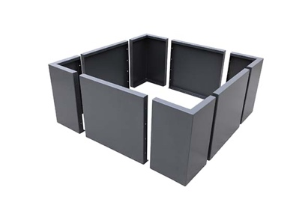 | RichardBrink_HochbeetModular_04 | A user-friendly online configurator is available on the Richard Brink website, providing customers with a simple, illustrative way of putting together the Modular raised bed.  Photo: Richard Brink GmbH & Co. KG

