Image | File name | Caption
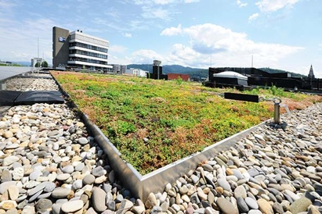 | RichardBrink_Gruendach_01 | Green roofs are an ideal way of fully exploiting the potential of roof surfaces and are a good example of modern, sustainable construction. The company Richard Brink has brought three integrated systems for extensive roof planting on the market.  Photo: Richard Brink GmbH & Co. KG
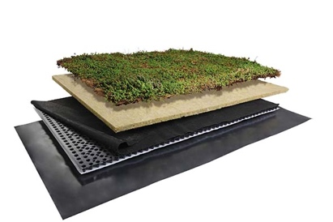 | RichardBrink_Gruendach_02 | The Easy roof planting system has a streamlined configuration, whereby all of the layers are rolled out across or placed on to the roof surface. It is characterised by its low weight, despite having a high water storage capacity.  Photo: Richard Brink GmbH & Co. KG
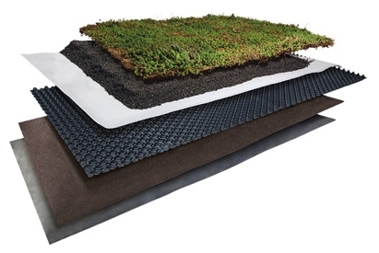 | RichardBrink_Gruendach_03 | By contrast, the Terra system is based entirely on a substrate layer. Through the use of different drain mats and installation heights, it is extremely flexible and can be adapted to the vegetation.  Photo: Richard Brink GmbH & Co. KG
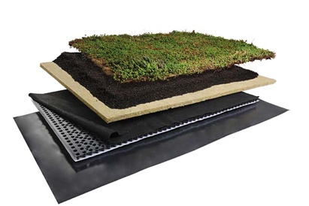 | RichardBrink_Gruendach_04 | The Bio system is the most sophisticated of the three. It combines the benefits of both the water storage mat and the substrate layer in one integrated solution. Thanks to its composition, it achieves the highest water storage capacity and is suitable for varied vegetation.  Photo: Richard Brink GmbH & Co. KG
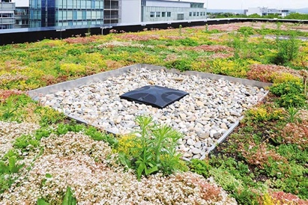 | RichardBrink_Gruendach_05 | Alongside the three integrated systems, Richard Brink offers compatible edging products such as substrate rails and can also supply coarse gravel.  Photo: Richard Brink GmbH & Co. KG

