Image | File name | Caption
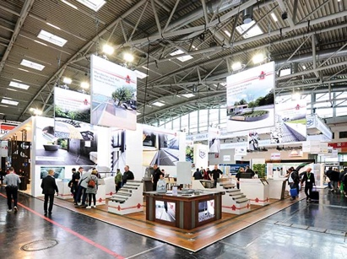 | RichardBrink_BAU2023_01 | Richard Brink used its substantial exhibition space to present its varied range of products at BAU 2023.  Photo: Richard Brink GmbH & Co. KG
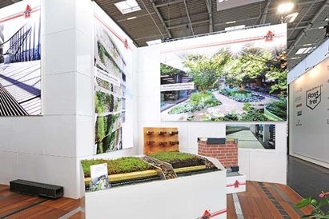 | RichardBrink_BAU2023_02 | This year’s highlights included the new integrated systems for extensive roof planting. The metal products manufacturer offers three different versions, with each of their components coming from a single source.  Photo: Richard Brink GmbH & Co. KG
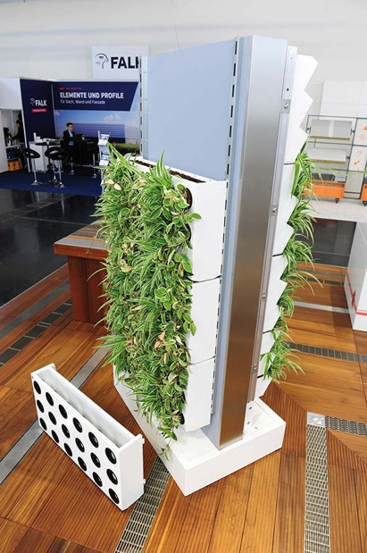 | RichardBrink_BAU2023_03 | With its modular construction, the Adam living wall for façade planting also gained a lot of attention.  Photo: Richard Brink GmbH & Co. KG
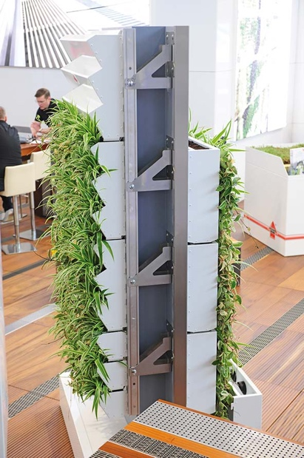 | RichardBrink_BAU2023_04 | The living wall is available in two different designs. Richard Brink produces three different substructures to ensure the wall is properly secured to the façade.  Photo: Richard Brink GmbH & Co. KG
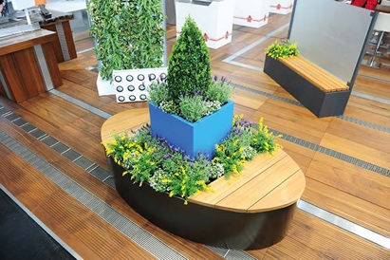 | RichardBrink_BAU2023_05 | There was no shortage of lush greenery at the exhibition stand, with plant boxes on display alongside the living walls.  Photo: Richard Brink GmbH & Co. KG
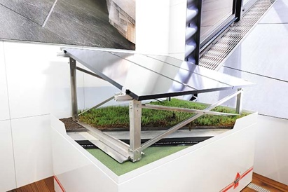 | RichardBrink_BAU2023_06 | Richard Brink now offers an additional mounting system for its solar substructures. This enables green roofs to flourish, even in the presence of photovoltaic systems.  Photo: Richard Brink GmbH & Co. KG
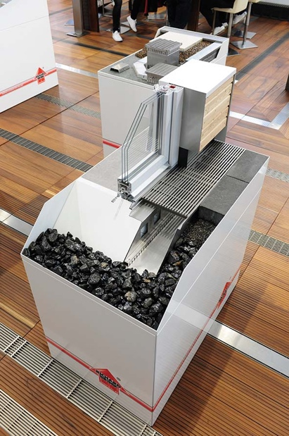 | RichardBrink_BAU2023_07 | Time-proven systems such as the Stabile Air façade channel shown here were also on display at the exhibition. The channel keeps a building’s base ventilated and is well suited for use in reveal areas.  Photo: Richard Brink GmbH & Co. KG
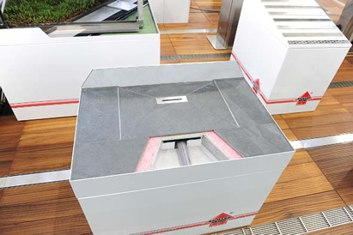 | RichardBrink_BAU2023_08 | Bathroom systems such as the Atrium shower tray rounded off the wide variety of products at the stand.  Photo: Richard Brink GmbH & Co. KG
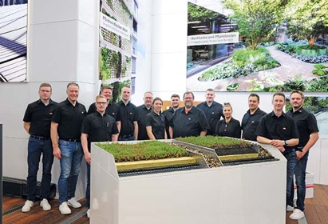 | RichardBrink_BAU2023_09 | The Richard Brink team were always on hand with help and advice for trade visitors. During the six days of the exhibition, they saw a lively influx of interested visitors and were really pleased with how the event went.  Photo: Richard Brink GmbH & Co. KG

