Image | File name | Caption
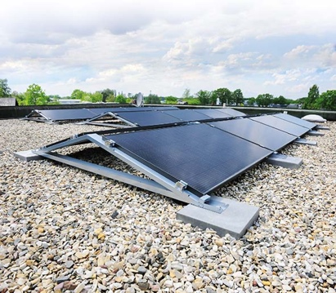 | RichardBrink_Miralux-System_01 | Richard Brink has further expanded its Miralux solar substructure portfolio.  Photo: Richard Brink GmbH & Co. KG
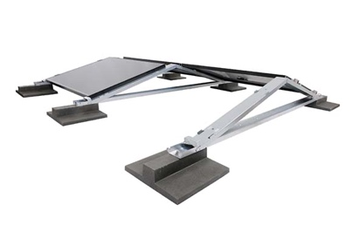 | RichardBrink_Miralux-System_02 | From now on, the substructures will be supplied with flexible module clamps as standard both in the east-west version shown here and in the south-facing mounting system.  Photo: Richard Brink GmbH & Co. KG
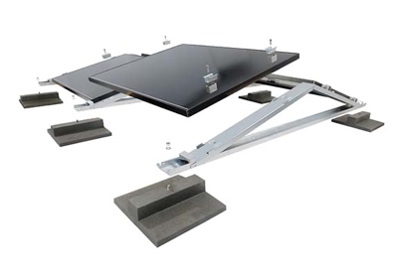 | RichardBrink_Miralux-System_03 | These systems, which form part of the Miralux Flex range, can be adjusted to hold all kinds of commercially available panel sizes.  Photo: Richard Brink GmbH & Co. KG
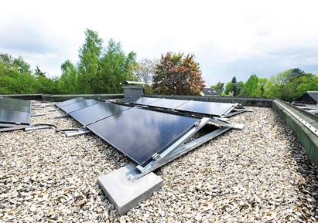 | RichardBrink_Miralux-System_04 | Their non-penetrative installation and easy handling allow the solar substructures to be assembled quickly and securely.  Photo: Richard Brink GmbH & Co. KG
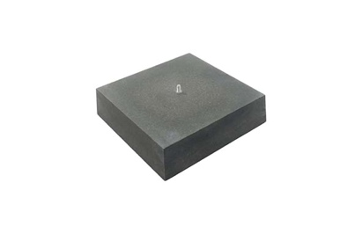 | RichardBrink_Miralux-System_05 | Two different types of ballast block with a base area of 400 x 400mm hold the substructures firmly in place. This square version weighs 34kg.  Photo: Richard Brink GmbH & Co. KG
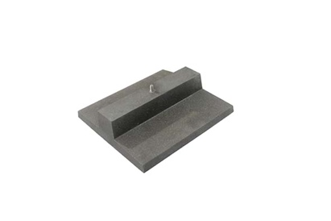 | RichardBrink_Miralux-System_06 | The 16kg model features a flat base panel and is especially suited to installing systems on gravel or green roofs.  Photo: Richard Brink GmbH & Co. KG
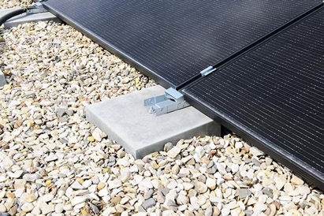 | RichardBrink_Miralux-System_07 | The ballast blocks raise the structure above the roof surface, making for a clean look and a system that’s easy to maintain.  Photo: Richard Brink GmbH & Co. KG
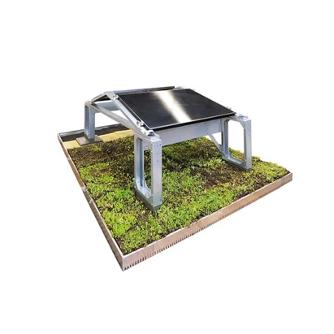 | RichardBrink_Miralux-System_08 | Richard Brink’s new solutions also make the combination of green roof and photovoltaics possible. The additional mounting system for the Miralux Flex enables solar panels to be assembled over existing or new extensive green roofs.  Photo: Richard Brink GmbH & Co. KG
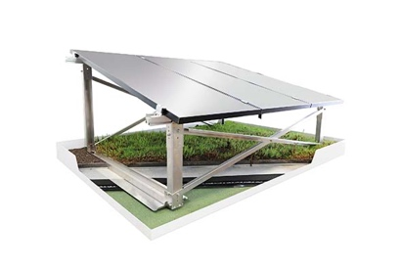 | RichardBrink_Miralux-System_09 | The brand-new Miralux Green system is available for east-west-facing panels and directly integrates the substructure into the green roof. Here, the plant cover and granulate also act as ballast layers.  Photo: Richard Brink GmbH & Co. KG

