Image | File name | Caption
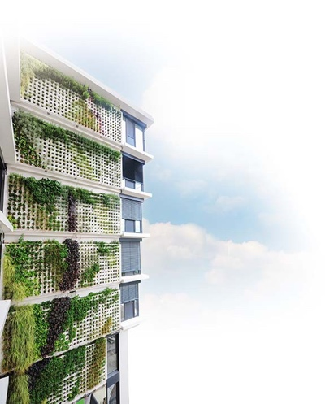 | RichardBrink_Adam_01 | The Adam living wall from the company Richard Brink is the ideal solution for large-scale façade planting. The metal products manufacturer has now expanded this area further.  Photo: Richard Brink GmbH & Co. KG
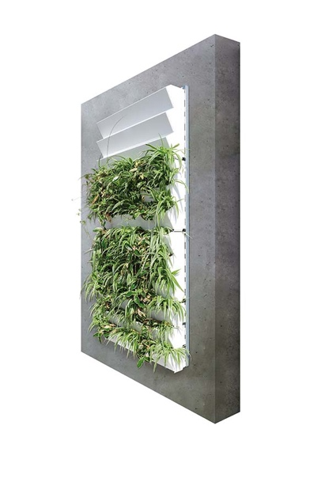 | RichardBrink_Adam_02 | Customers can choose from three different substructures for securing the living wall to the façade. Here you can see the self-supporting version, which combines top-hat rails with stepped plant cassettes for vertical planting.  Photo: Richard Brink GmbH & Co. KG
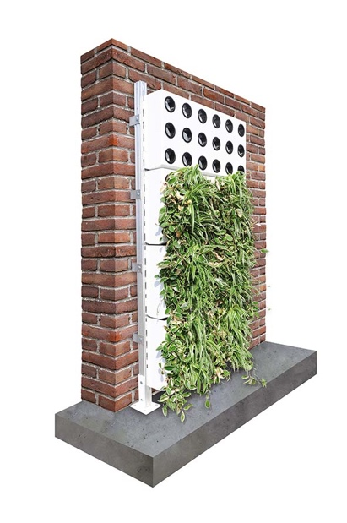 | RichardBrink_Adam_03 | The second version is designed for walls that are unable to bear the static load alone. It features integrated feet that are set down on a foundation. This places a lot of weight on the base, while additional fixtures counter the tipping load.  Photo: Richard Brink GmbH & Co. KG
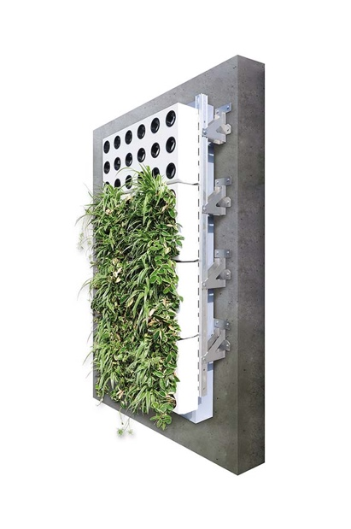 | RichardBrink_Adam_04 | The plant cassettes, such as the vertical modules shown here that are filled from the side, can also be combined with a special substructure for thermal insulation composite systems.  Photo: Richard Brink GmbH & Co. KG
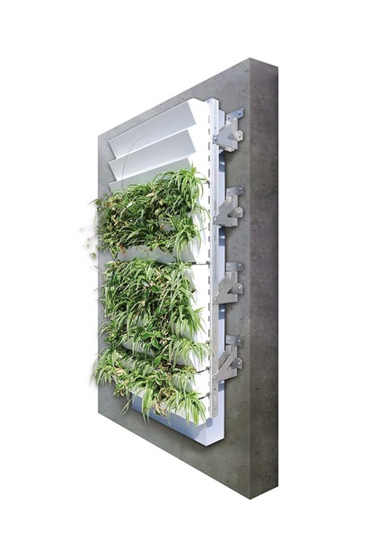 | RichardBrink_Adam_05 | Also a self-supporting system, the third substructure is designed to incorporate a 160mm-thick layer of insulation used on the wall exterior.  Photo: Richard Brink GmbH & Co. KG
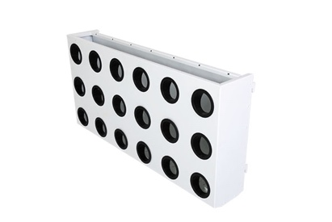 | RichardBrink_Adam_06 | The vertical cassettes are filled by simply inserting plants into the pre-cut holes.  Photo: Richard Brink GmbH & Co. KG
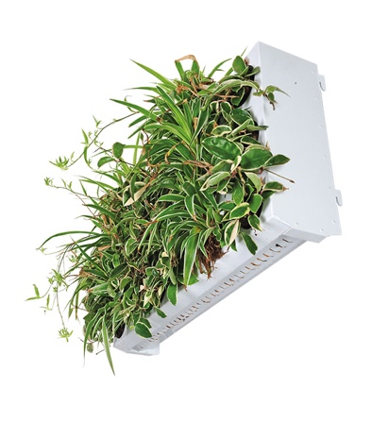 | RichardBrink_Adam_07 | Rain and irrigation water can easily seep down through the cassettes thanks to perforations in the base.  Photo: Richard Brink GmbH & Co. KG
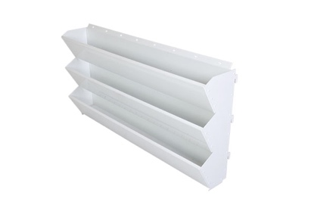 | RichardBrink_Adam_08 | The stepped plant cassettes enable vertical planting in a substrate depth of 120mm. Here you can see the upper backward bend complete with punch holes, which is able to hold customary drip irrigation hoses.  Photo: Richard Brink GmbH & Co. KG
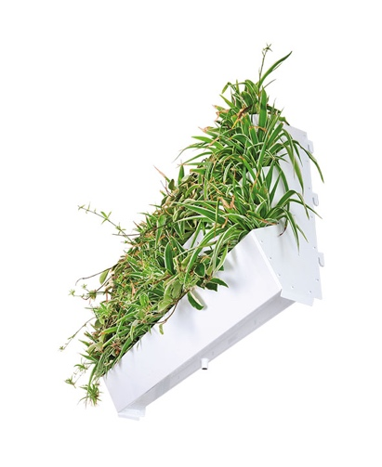 | RichardBrink_Adam_09 | The plant cassette’s bottom tier features fully welded frames with integrated run-off nozzles for the controlled and targeted drainage of excess water.  Photo: Richard Brink GmbH & Co. KG
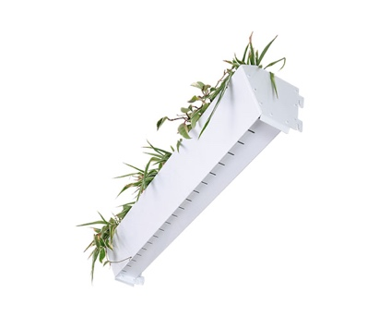 | RichardBrink_Adam_10 | Besides multi-tiered cassettes, individual boxes are also available that can be planted from above.  Photo: Richard Brink GmbH & Co. KG
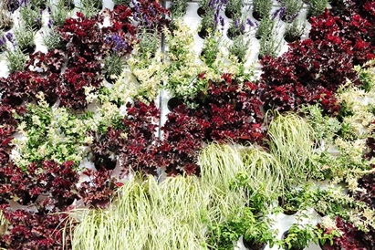 | RichardBrink_Adam_11 | Whether vertical or stepped plant cassettes are used – together, the modular solutions allow extensive, seamless planting in just a short space of time.  Photo: Richard Brink GmbH & Co. KG

