Image | File name | Caption
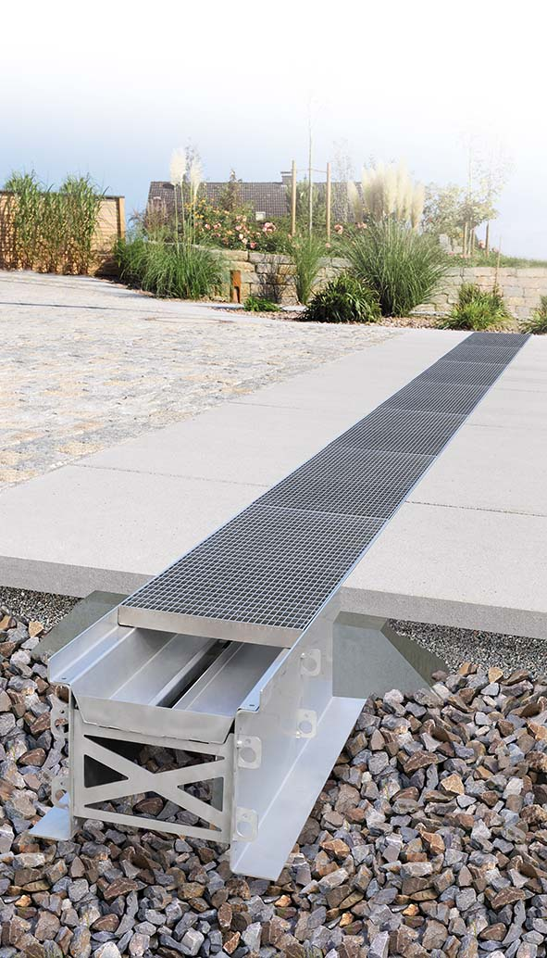 | RichardBrink_RigoMax_01 | With the new RigoMax, the company Richard Brink presents an XXL infiltration channel which initially collects and then gradually drains large volumes of precipitation.  Photo: Richard Brink GmbH & Co. KG
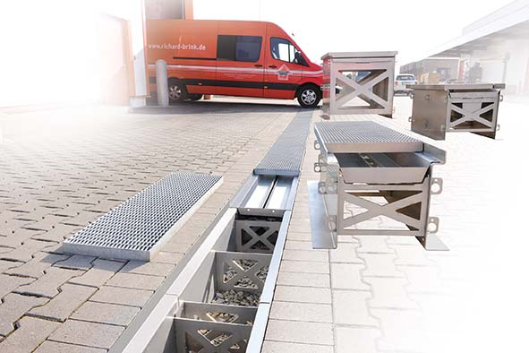 | RichardBrink_RigoMax_02 | The channel was specially designed to be used in urban spaces and areas exposed to traffic that are not connected to the sewer system. Thanks to its stable construction, it can withstand wheel loads of 5 to 10 tons, depending on the selected grating cover.  Photo: Richard Brink GmbH & Co. KG
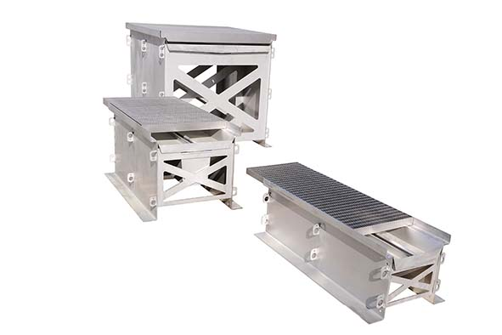 | RichardBrink_RigoMax_03 | The metal products manufacturer offers the RigoMax in a variety of lengths, widths and heights. Its storage volume thus ranges from 90 to 970 litres.  Photo: Richard Brink GmbH & Co. KG
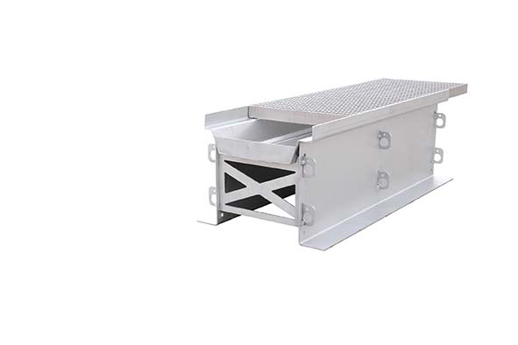 | RichardBrink_RigoMax_04 | Integrated connection braces and angle connectors fixed to the outside walls, designed to be set in concrete, increase the channel’s stability.  Photo: Richard Brink GmbH & Co. KG
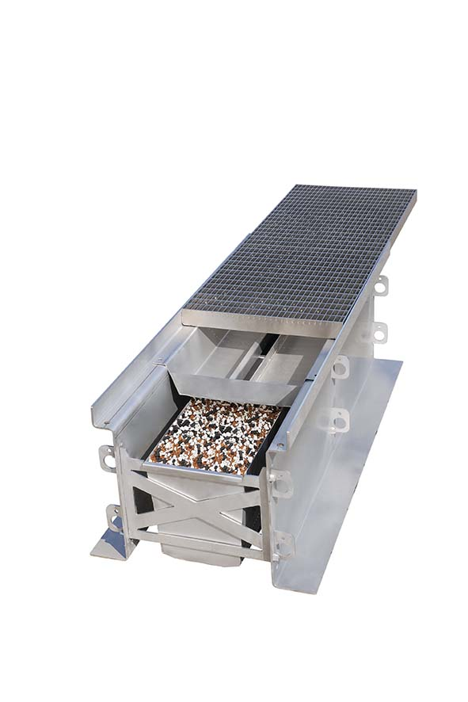 | RichardBrink_RigoMax_05 | The new products also feature integrated filter inserts. Thanks to its upturned edges, the upper insert holds back not only coarse dirt but also tyre wear particles and microplastics. The lower insert is able to filter out substances contained in the water.  Photo: Richard Brink GmbH & Co. KG
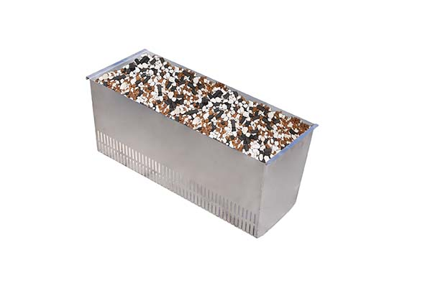 | RichardBrink_RigoMax_06 | Thanks to its ability to sift out components such as heavy metals effectively, the optional second filter also meets regulations often applicable in public areas.  Photo: Richard Brink GmbH & Co. KG
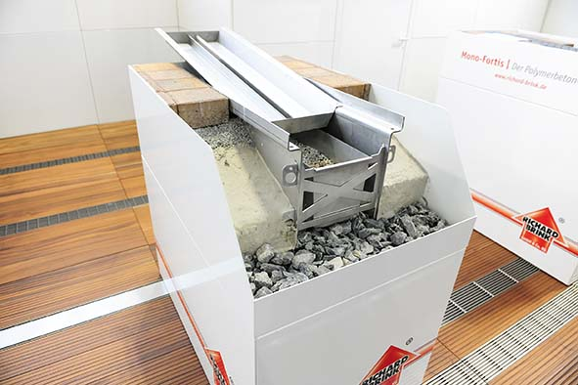 | RichardBrink_RigoMax_07 | Richard Brink GmbH & Co. KG presented its new product live, for the very first time, at the IFAT 2022 in Munich. Installation locations were simulated in order to illustrate the functionality of the channels.  Photo: Richard Brink GmbH & Co. KG

