Image | File name | Caption
 | RichardBrink_PflanzwandAdam_01 | With its new Adam living wall, the company Richard Brink now provides a solution for large-scale façade planting.  Photo: Richard Brink GmbH & Co. KG
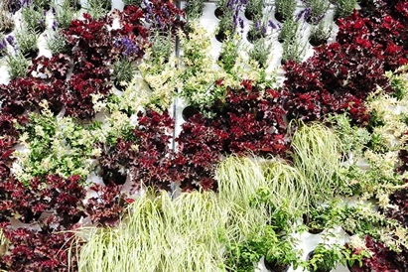 | RichardBrink_PflanzwandAdam_02 | The modular structure enables plant cassettes to be installed alongside one another flexibly, in line with individual project dimensions.  Photo: Richard Brink GmbH & Co. KG
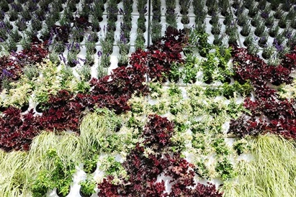 | RichardBrink_PflanzwandAdam_03 | The 2mm-thick aluminium cassettes each accommodate up to 18 plants in the standard version and create a highly appealing green space when several cassettes are installed together.  Photo: Richard Brink GmbH & Co. KG

