Image | File name | Caption
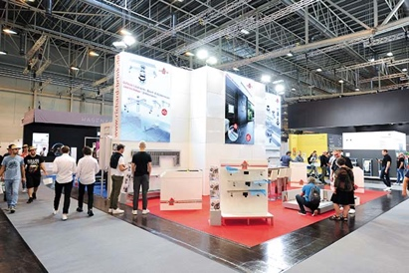 | RichardBrink_SHK2022_01 | The company Richard Brink took part in the SHK Essen 2022 for the very first time, presenting products from its bathroom and kitchen systems.  Photo: Richard Brink GmbH & Co. KG
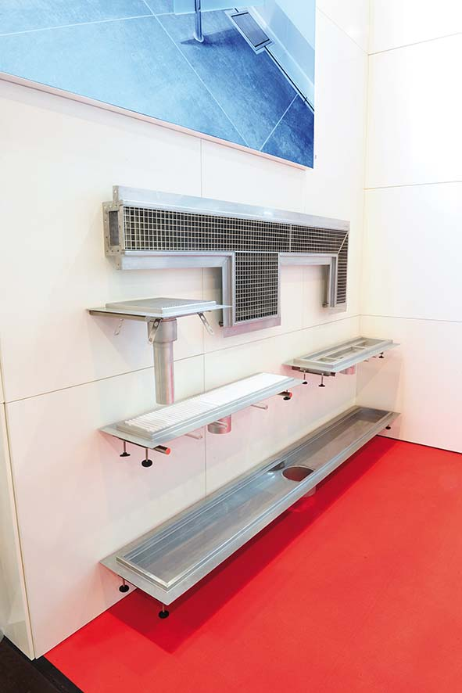 | RichardBrink_SHK2022_02 | The metal products manufacturer showcased, for example, its Collecta industrial, shower and kitchen channel with corresponding drain points, suitable for collecting even large volumes of water in indoor spaces.  Photo: Richard Brink GmbH & Co. KG
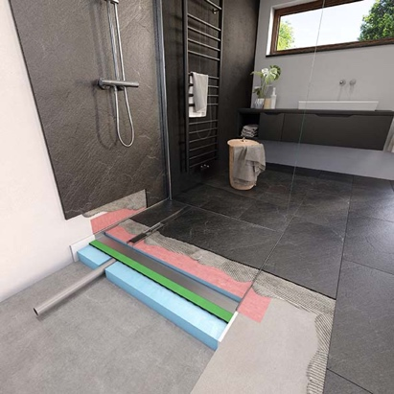 | RichardBrink_SHK2022_03 | The Atrium level-access shower tray was another product highlight at the booth. The barrier-free integrated system provides customers with all the requisite components in one unit which, thanks to the fully welded stainless steel base, boasts an absolutely impenetrable second drainage level.  Photo: Richard Brink GmbH & Co. KG
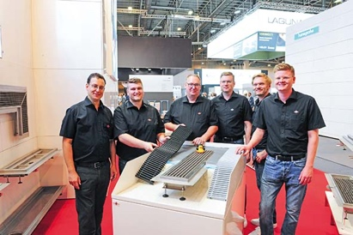 | RichardBrink_SHK2022_04 | The team from Richard Brink GmbH & Co. KG happily advised and supported the trade visitors over the four days of the trade fair.  Photo: Richard Brink GmbH & Co. KG

