Image | File name |  | Caption
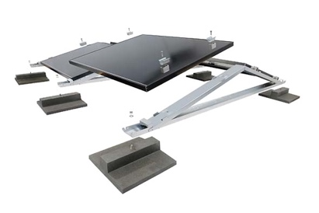 | RichardBrink_MiraluxFlex_01 |  | The MiraluxFlex is the latest addition to Richard Brink’s range of solar substructures. In the east-west facing version, the systems now come with module clamps to facilitate the flexible use of commercially available panels.  Photo: Richard Brink GmbH & Co. KG
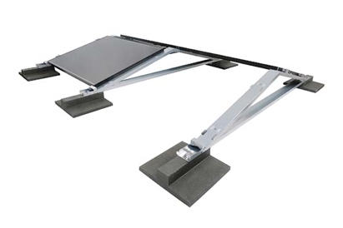 | RichardBrink_MiraluxFlex_02 |  | The fixtures are installed at predefined points to either side of the mounting frame made from hot-dip galvanised steel with a Magnelis coating or, on request, from aluminium.  Photo: Richard Brink GmbH & Co. KG
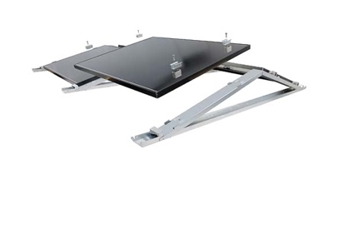 | RichardBrink_MiraluxFlex_03 |  | Thanks to the clamps, the system can easily hold modules measuring between 30mm and 50mm tall and between 900mm and 1,100mm deep.  Photo: Richard Brink GmbH & Co. KG
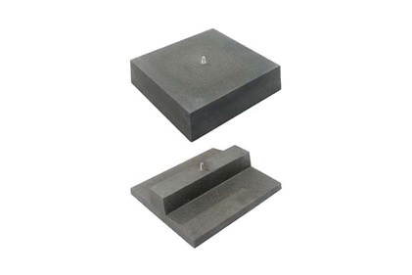 |  | RichardBrink_MiraluxFlex_04 |  | Customers can also choose from two types of ballast block: the top, square version with a weight of approx. 34kg and the bottom approx. 16kg block, which can be used for installation in gravel beds or on green roofs.  Photo: Richard Brink GmbH & Co. KG
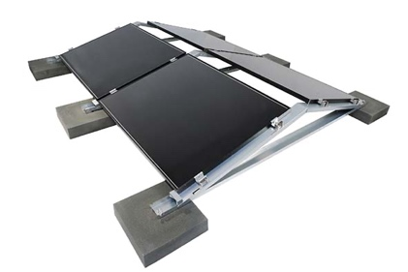 |  | RichardBrink_MiraluxFlex_05 |  | The solar substructures complete with fixtures and ballast blocks provide a high-performance system and an ideal solution for every type of solar panel and roof structure.  Photo: Richard Brink GmbH & Co. KG

