Image | File name | Caption
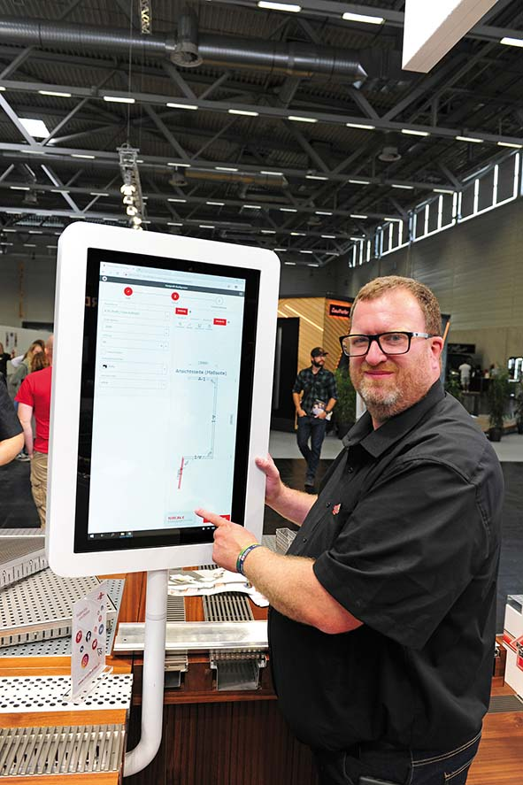 | RichardBrink_KantprofilKonfigurator_01 | The company Richard Brink introduced its new online configurator for edge profiles for the very first time at the 2022 DACH+HOLZ International in Cologne.  Photo: Richard Brink GmbH & Co. KG
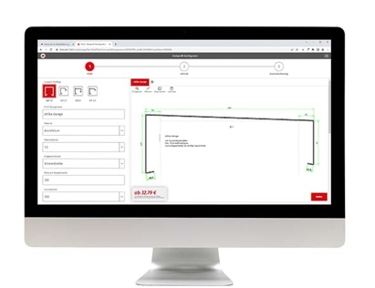 | RichardBrink_KantprofilKonfigurator_02 | In the first step, parameters such as material, thickness, heights, widths, projections, slope angles, fixtures and mount spacing can be determined based on different types of profiles.  Photo: Richard Brink GmbH & Co. KG
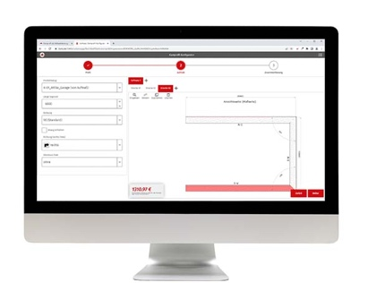 | RichardBrink_KantprofilKonfigurator_03 | The required measurements are then calculated, with a number of additional options available. Several sections can be combined in each set of measurements.  Photo: Richard Brink GmbH & Co. KG
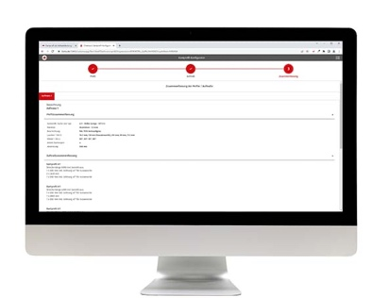 | RichardBrink_KantprofilKonfigurator_04 | Once the measurements are complete, a detailed list of configurations is generated for the customer, who can order their profiles directly via the online shop.  Photo: Richard Brink GmbH & Co. KG

