Image | File name |  | Caption
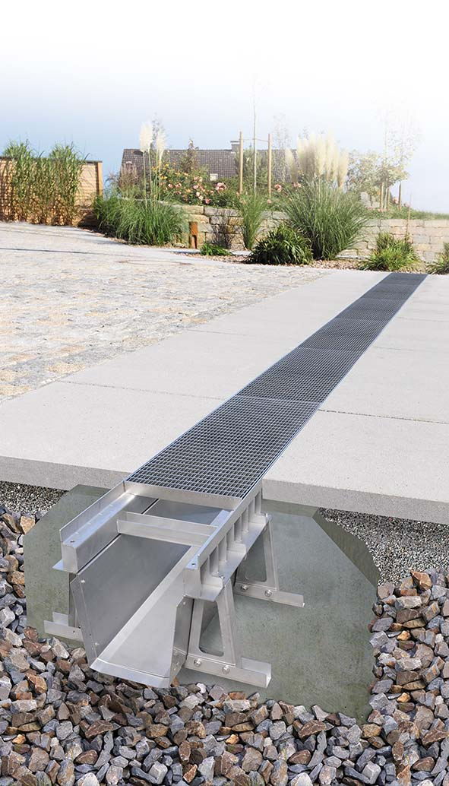 | RichardBrink_FerroMax_01 |  | The new FerroMax XXL water collection channel from Richard Brink is ideal for quickly holding large volumes of precipitation in traffic or residential areas where ground surfaces tend to be sealed.  Photo: Richard Brink GmbH & Co. KG
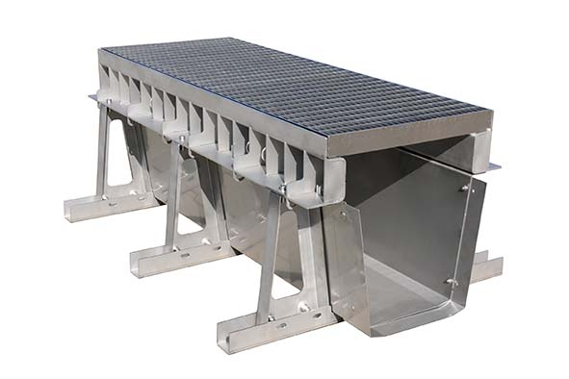 | RichardBrink_FerroMax_02 |  | The channel is able to temporarily store even large amounts of water before directing it towards the sewer system in a controlled manner.  Photo: Richard Brink GmbH & Co. KG
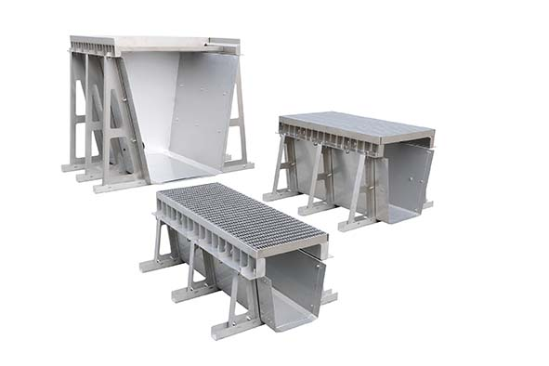 | RichardBrink_FerroMax_03 |  | The FerroMax is available in different dimensions as determined by the specific construction project and individual requirements. Depending on the selected version, it has a storage volume of between 102 and 900 litres per running metre.  Photo: Richard Brink GmbH & Co. KG
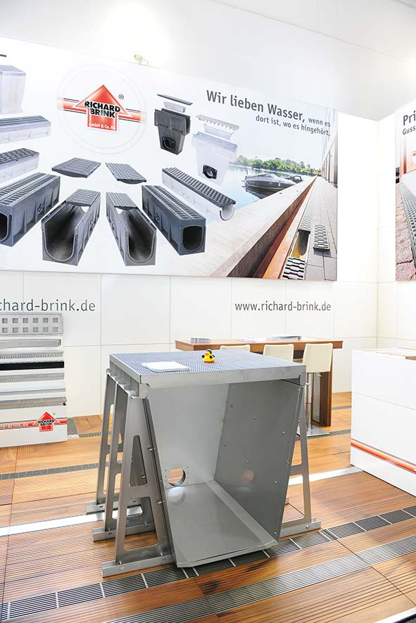 |  | RichardBrink_FerroMax_04 |  | The metal products manufacturer presented its new product, available in either hot-dip galvanised steel or stainless steel, for the very first time at the IFAT 2022 in Munich.  Photo: Richard Brink GmbH & Co. KG
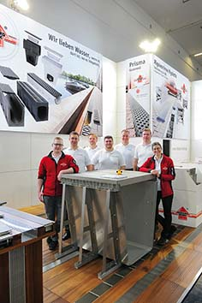 |  | RichardBrink_FerroMax_05 |  | Visitors to the trade fair stand were able to gain a good understanding of the FerroMax, which stood out in particular due to its impressive size.  Photo: Richard Brink GmbH & Co. KG

