Image | File name |  | Caption
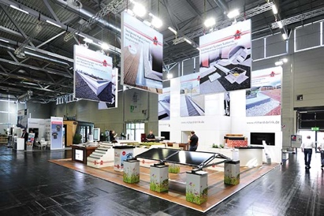 | RichardBrink_Nachbericht_DACH+HOLZ22_01 |  | Richard Brink GmbH & Co. KG presented its established range of dewatering and roof systems at this year’s DACH+HOLZ International in Hall 6 of Cologne Trade Fair Grounds.  Photo: Richard Brink GmbH & Co. KG
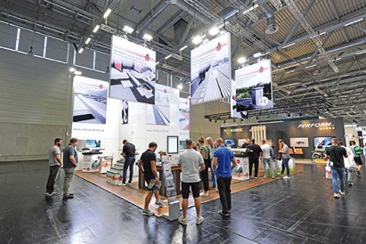 | RichardBrink_Nachbericht_DACH+HOLZ22_02 |  | The metal products manufacturer certainly piqued the interest of the exhibition visitors and embraced the chance to speak to people face-to-face at the booth.  Photo: Richard Brink GmbH & Co. KG
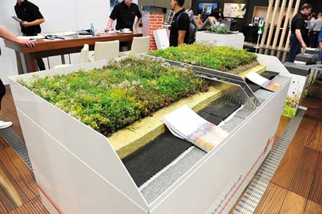 | RichardBrink_Nachbericht_DACH+HOLZ22_03 |  | The presentation of the new integrated system for green roofs was especially well received at the booth. It incorporates Richard Brink’s time-proven gravel stops, a drainage element, a water storage mat and suitable planting for extensive vegetation.  Photo: Richard Brink GmbH & Co. KG
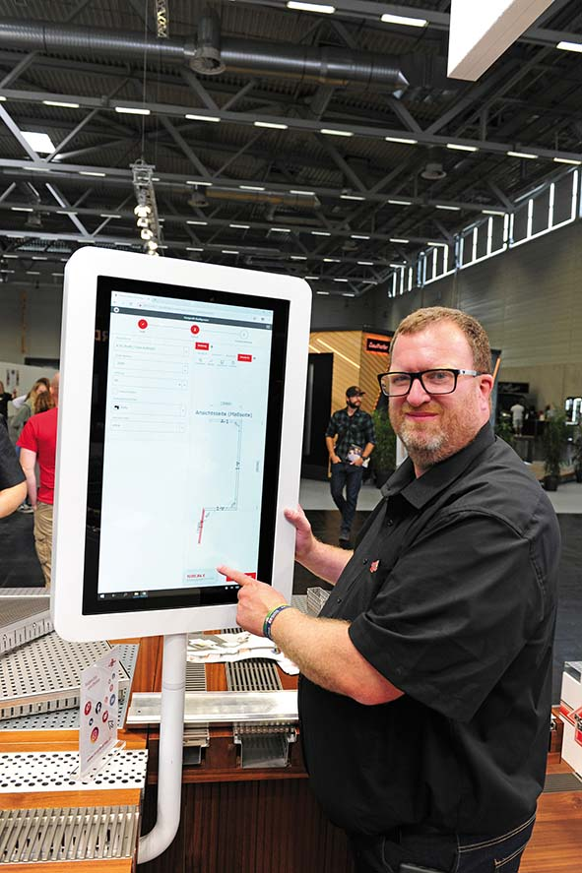 |  | RichardBrink_Nachbericht_DACH+HOLZ22_04 |  | Another new addition was the online configurator for edge profiles. Customers can create bespoke solutions in just a few clicks, which they can then order directly from the metal products manufacturer.  Photo: Richard Brink GmbH & Co. KG
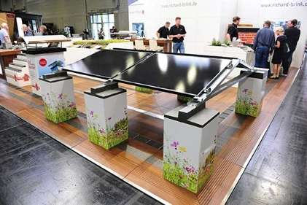 |  | RichardBrink_Nachbericht_DACH+HOLZ22_05 |  | Other products on display included the MiraluxFlex solar substructure.  Photo: Richard Brink GmbH & Co. KG
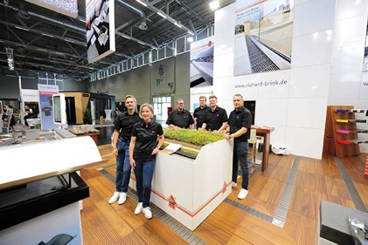 |  | RichardBrink_Nachbericht_DACH+HOLZ22_06 |  | The team from Richard Brink were happy to go into detail with visitors about the presented products over the four exhibition days and were really pleased with how the trade fair went.  Photo: Richard Brink GmbH & Co. KG

